Comprehensive Digital Evidence Acquisition and Command-Line Analysis using FTK Imager, WinPmem, and Volatility
EXPERIMENT NO: 01

DATE:

- AIM

To perform a complete forensic acquisition and analysis lifecycle by imaging non-volatile storage using AccessData FTK Imager, capturing live volatile memory (RAM) using the WinPmem command-line utility, and analyzing the extracted memory dump using Volatility 3 commands via the PassMark Volatility Workbench.

SOFTWARE / TOOLS REQUIRED

  - Operating System: Windows OS

Forensics Tools:
    - AccessData FTK Imager (GUI for non-volatile physical drive imaging)
    - WinPmem (winpmem_mini_x64_rc2.exe) (CLI tool for volatile memory capture)
    - Volatility 3 Framework (vol.exe / PassMark Volatility Workbench V3.0)
  - Hardware: Evidence PC/Workstation, Target Storage Drive (hp v221w 16GB USB Device).

DESCRIPTION

A thorough digital forensic investigation requires collecting both data at rest and data in motion using strict operational procedures.
  - Non-Volatile Memory Acquisition: AccessData FTK Imager creates mathematically verifiable, bit-by-bit physical images of storage devices (saved as Raw/dd) without altering the original evidence.
  - Volatile Memory (RAM) Acquisition: Command-line utilities like WinPmem load a specialized kernel driver (pme98A2.tmp) to read physical memory directly. Executing

this via CMD writes active processes, network connections, and decrypted keys to a raw dump file (.raw).
  - Volatile Memory Analysis (CLI): Volatility 3 is a framework for analyzing RAM dumps. By passing specific parameters and plugins (e.g., -f <image_path> windows.pslist.PsList) into the command line or workbench, investigators can reconstruct the system's live state and identify suspicious processes.

PROCEDURE

Part A: Acquiring Non-Volatile Memory (Disk Image) using FTK Imager Step 1: Select the Source Type
Open FTK Imager as an Administrator. Navigate to File > Create Disk Image. In the Select Source dialog, choose Physical Drive.

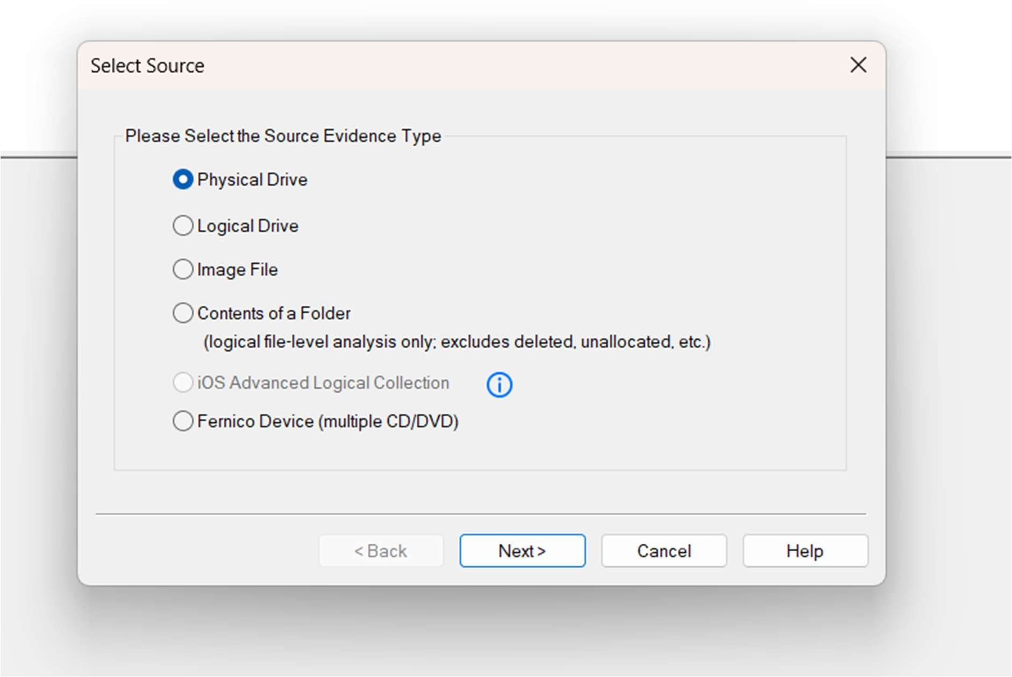
Figure 1: Selecting Physical Drive as the source evidence type

Step 2: Select the Specific Drive

Select the target evidence drive (\\.\PHYSICALDRIVE1 - hp v221w USB Device [16GB USB]) from the dropdown.
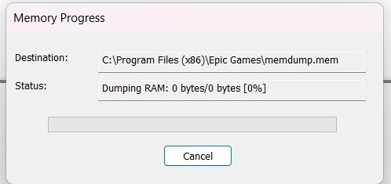
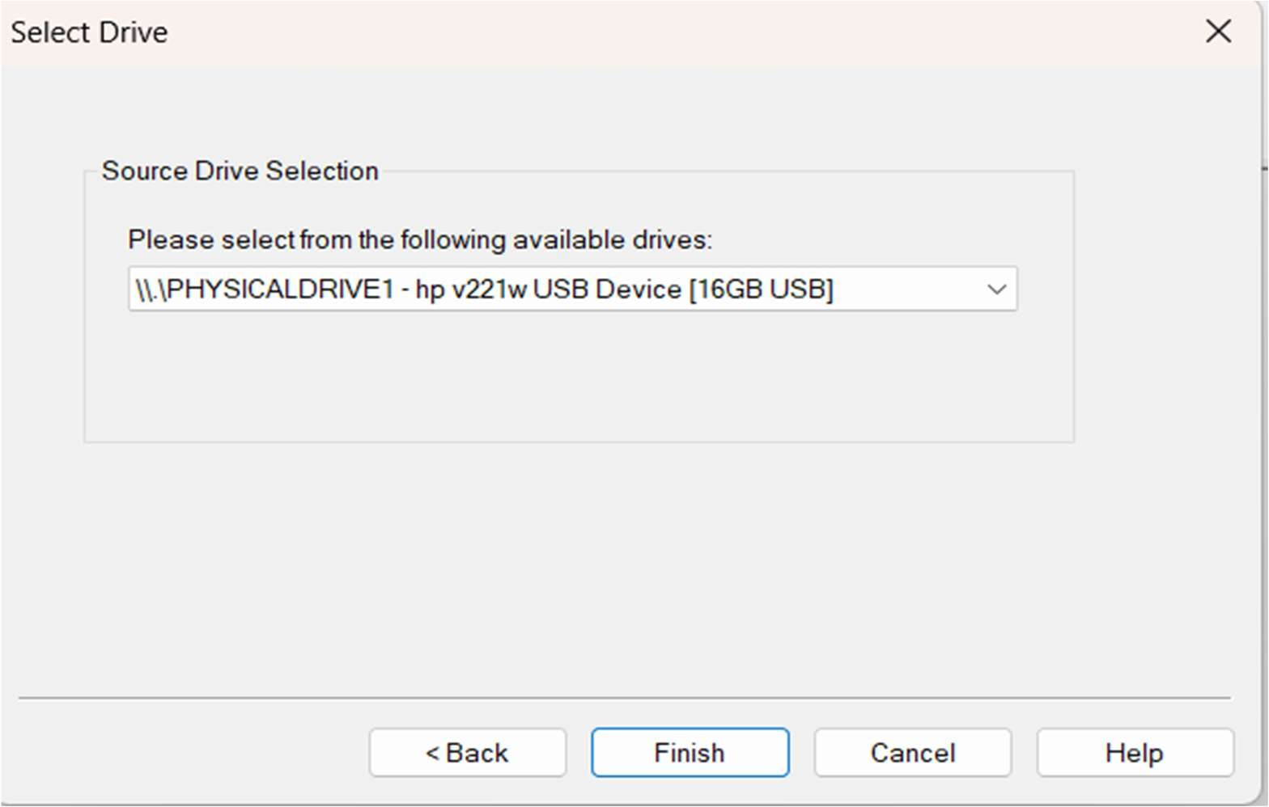

Figure 2: Selecting the target USB device for acquisition

Step 3: Choose the Image Type

Select Raw (dd) as the destination image type to create a pure bitstream copy.
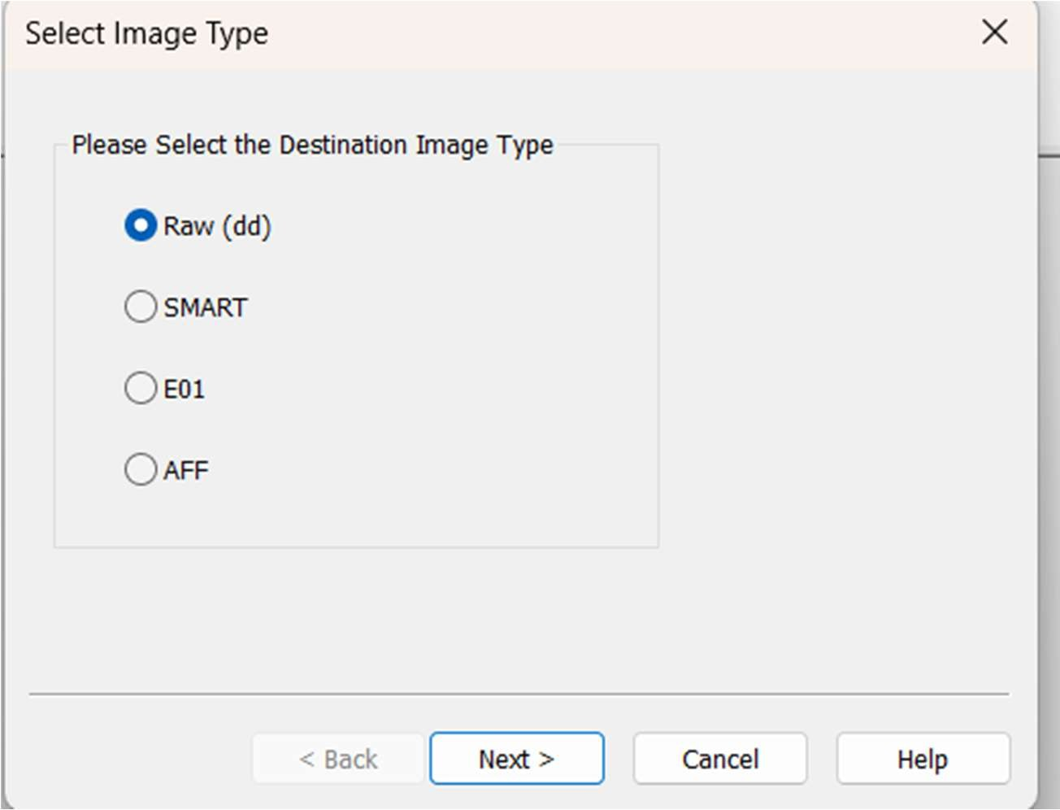

Figure 3: Configuring the destination image format to Raw (dd)

Step 4: Enter Evidence Item Information

Provide the standardized case details to maintain the chain of custody:

- Case Number: 99240040009

Evidence Number: 1

- Unique Description: Examine

- Examiner: Abinesh S

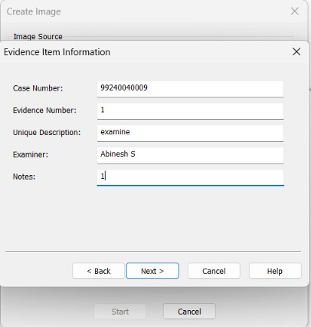

Figure 4: Entering the forensic case and examiner details

Step 5: Configure Image Destination

Set the destination folder to A:\DF\Digital_Forensics_Lab\Experiment-01-FTK-Imager\Results and the filename to Result. Set the Fragment Size to 20 MB and check Verify images after they are created.

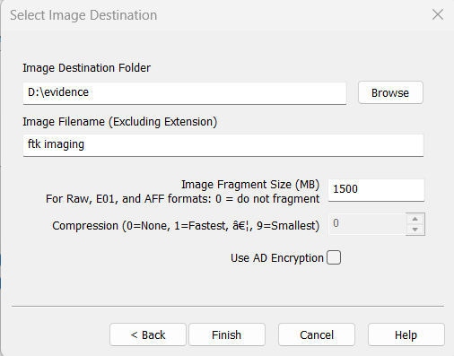

Figure 5: Setting the destination path, filename, and fragmentation size

Step 6: Monitor Acquisition Progress & Hash Verification

Click Start. Once complete, FTK Imager hashes the original drive and the newly created image. Review the Drive/Image Verify Results.
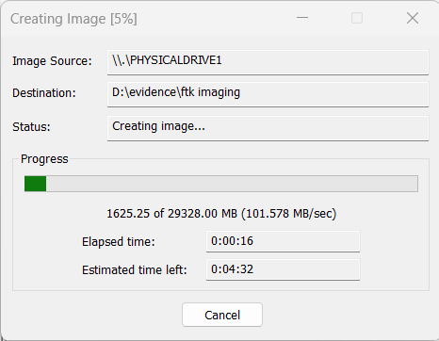

Figure 6: Disk imaging progress tracking

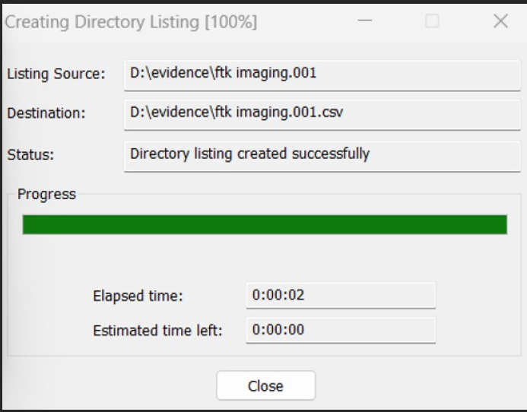

Figure 7: Successful verification of MD5 and SHA1 hashes

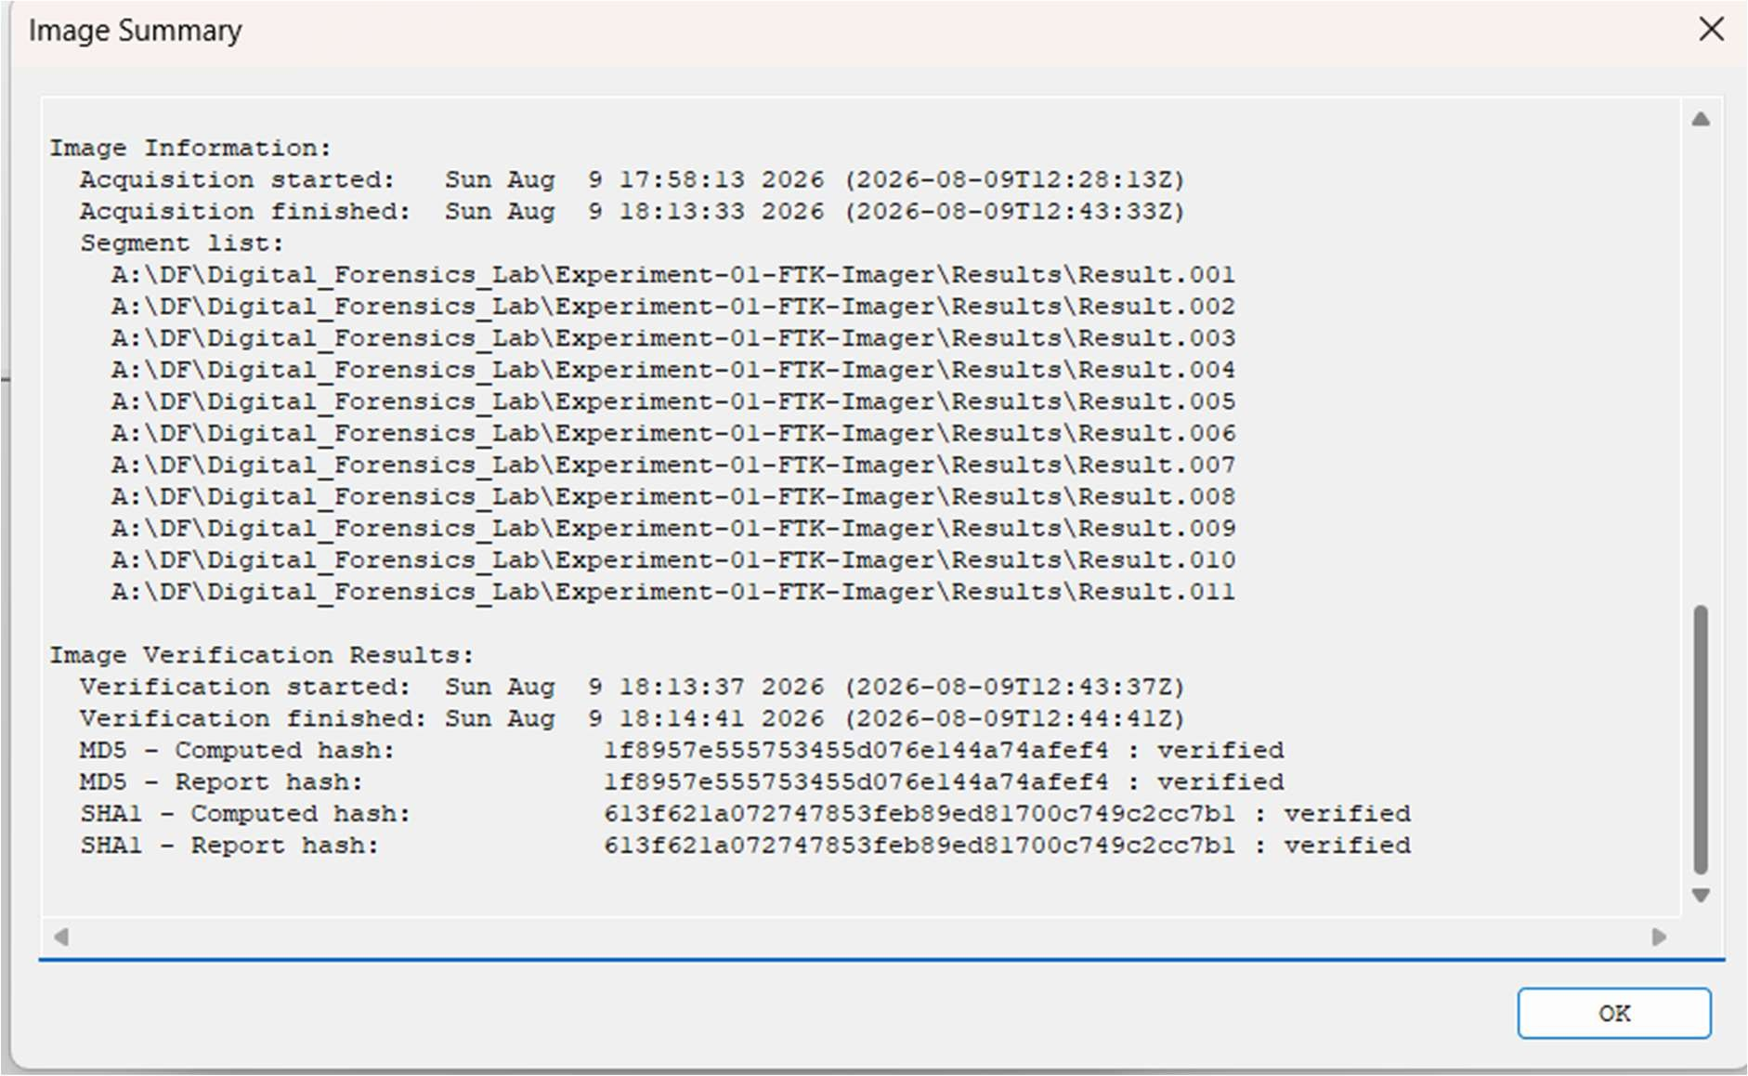
Figure 8: Image Summary detailing the hash verification results and segment list

Part B: Acquiring Volatile Memory (RAM) using WinPmem CMD Step 1: Launch Command Prompt
Press Win + R, type cmd, and press Ctrl + Shift + Enter to open the Command Prompt as an

Administrator.

Step 2: Navigate to Directory

Use the cd command to navigate to the folder containing the WinPmem executable: DOS
A:

cd \DF

Step 3: Check Available Parameters

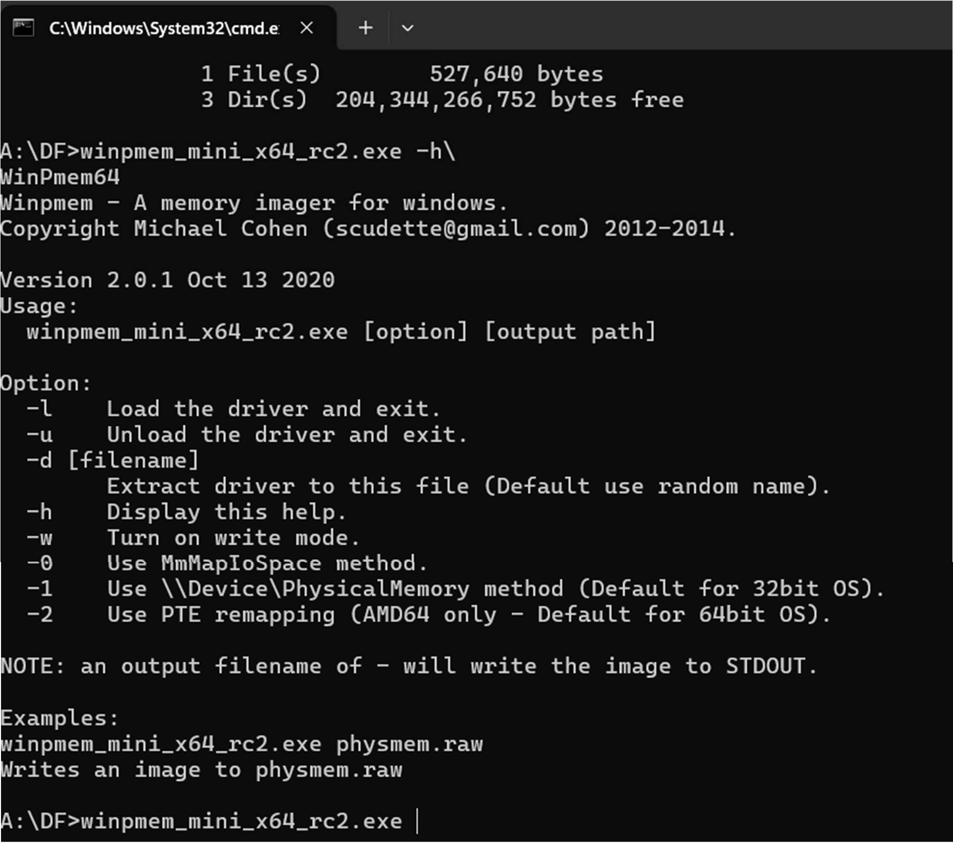
Execute the help command to view the WinPmem usage parameters: DOS winpmem_mini_x64_rc2.exe -h

Figure 9: Viewing the WinPmem help menu and available parameters

Step 4: Execute Memory Capture Command

Run the memory extraction command, specifying the output filename abi.raw. The utility will map the physical memory and write it to the file:
DOS

winpmem_mini_x64_rc2.exe abi.raw

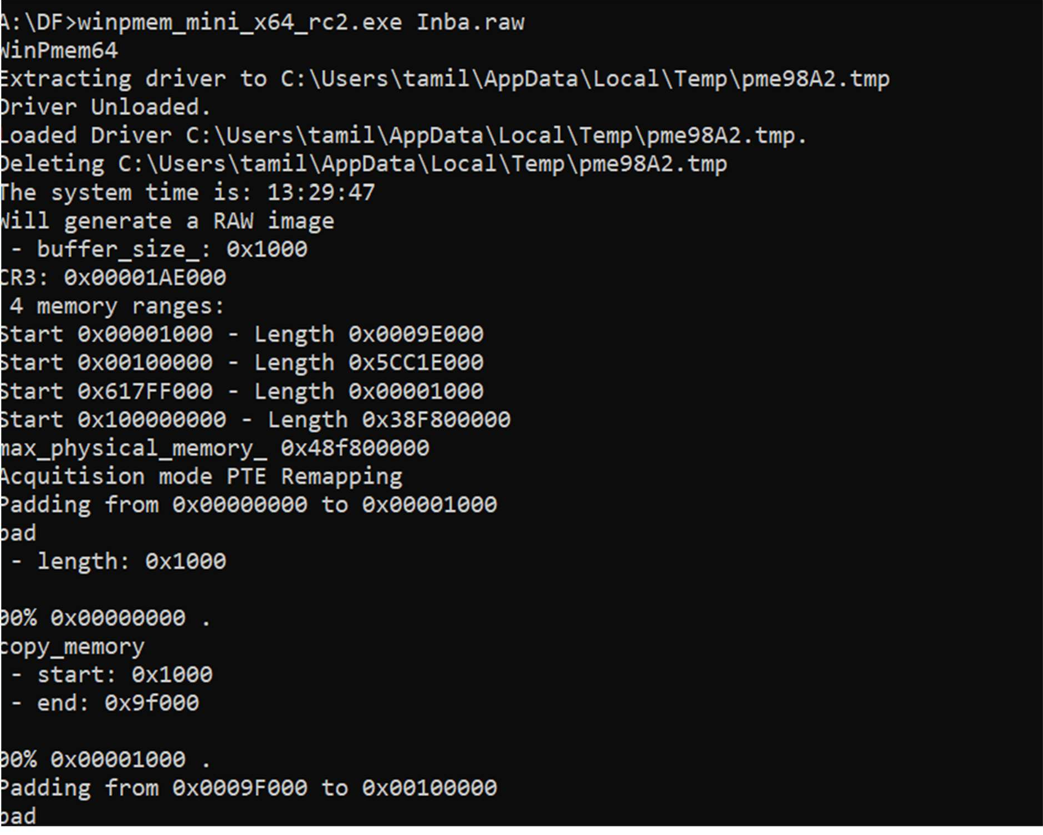

Figure 10: Initializing WinPmem and loading the extraction driver
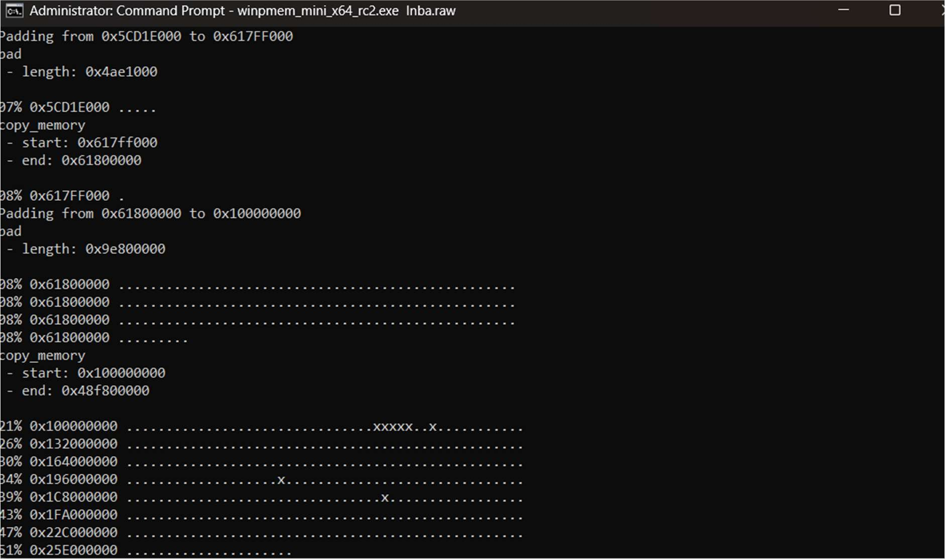
Figure 11: Memory capture in progress

Step 5: Verification of Dump

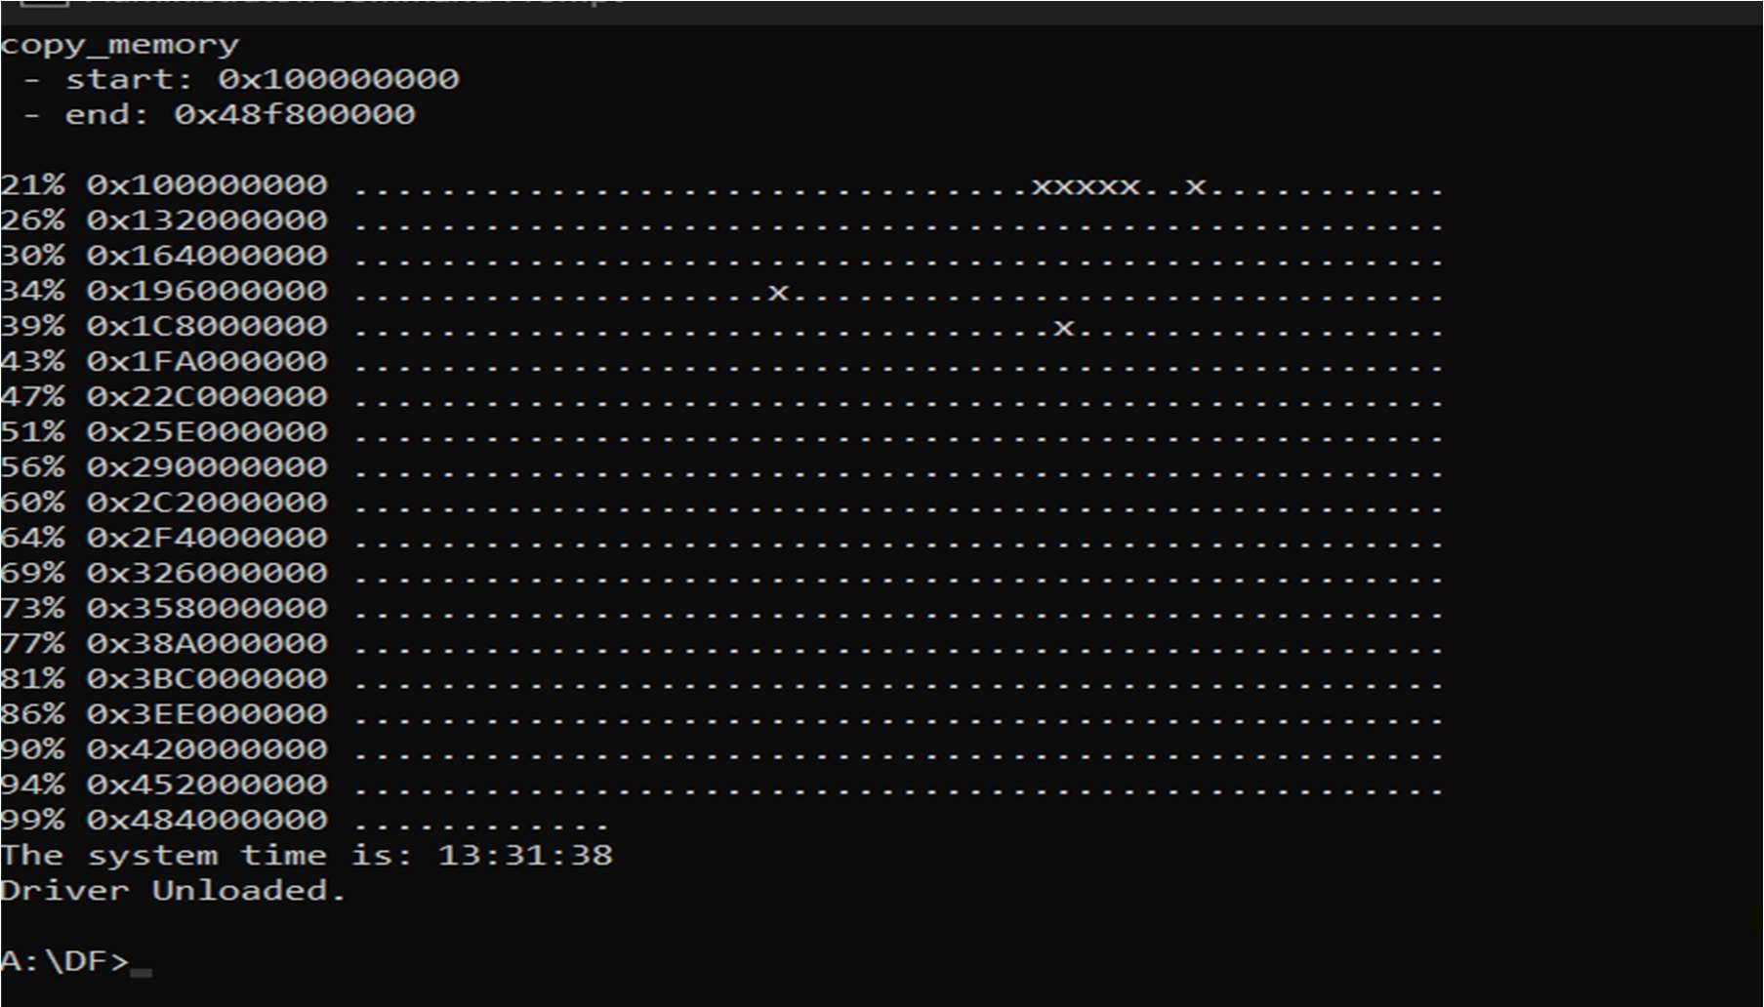
Wait for the terminal to display Driver Unloaded. Navigate to the directory to verify the 18.2 GB abi.raw file.
Figure 12: Successful completion of the volatile memory capture

Part C: Volatile Memory Analysis using Volatility CLI / Workbench

Step 1: Launch Volatility Environment

Open PassMark Volatility Workbench (which acts as a GUI frontend for vol.exe).
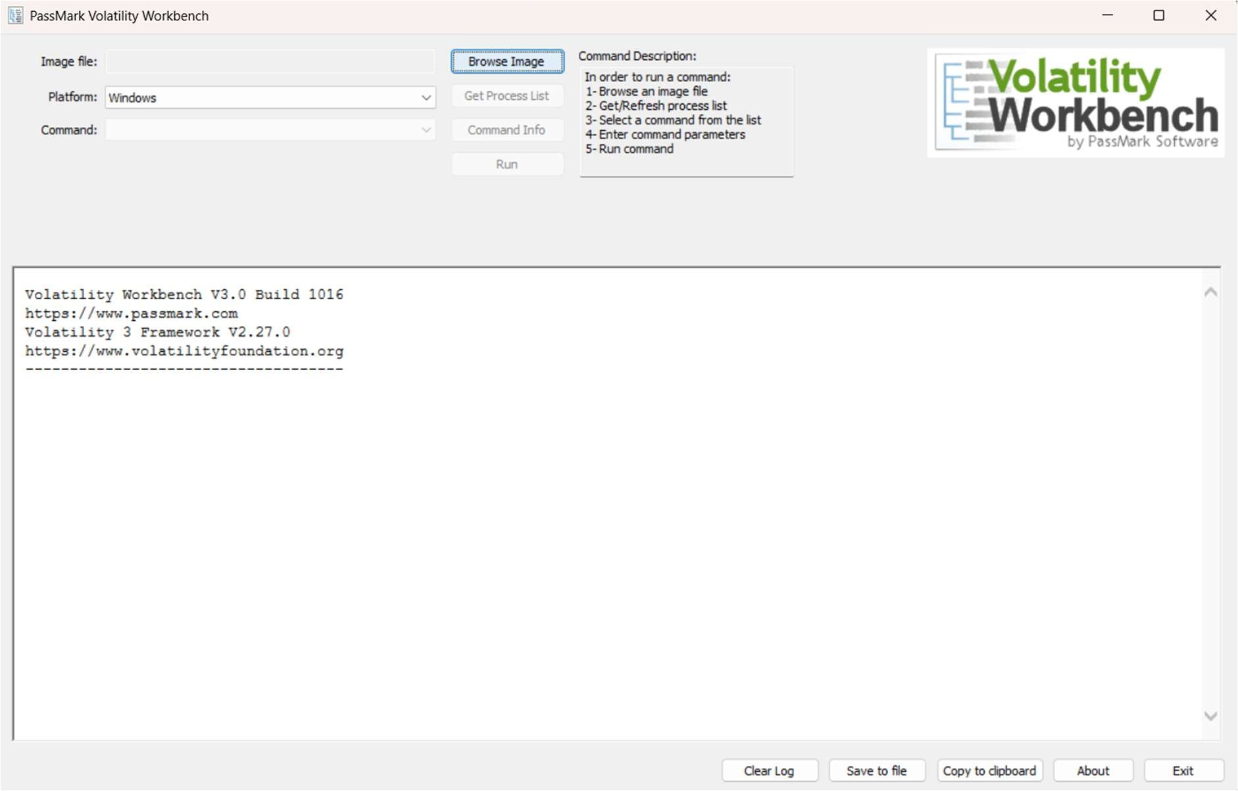
Figure 13: The default interface of PassMark Volatility Workbench

Step 2: Construct and Execute the Volatility Command

To parse the captured memory and list the active processes, load A:\DF\Inba.raw via Browse Image, select the Windows platform, choose windows.pslist.PsList from the dropdown, and click Run.
The console executes the following command in the background:

DOS

"C:\Users\tamil\Downloads\VolatilityWorkbench\vol.exe" -f "A:\DF\Inba.raw" windows.pslist.PsList

Or

Use the workbench
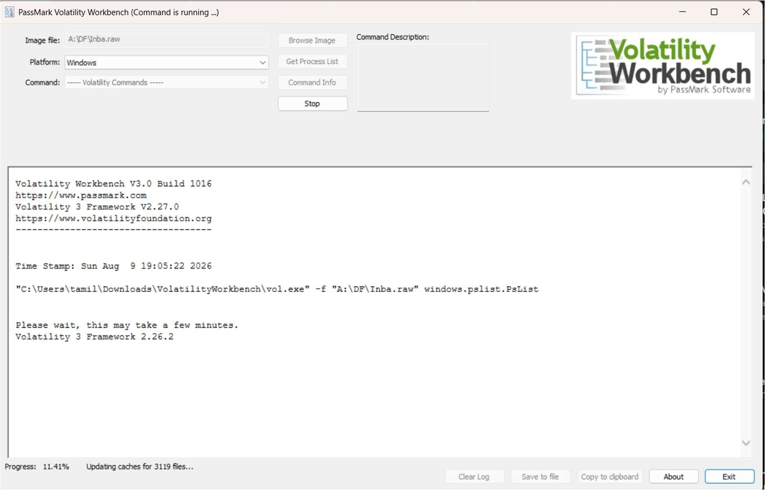
Figure 14:Execution of Volatility for the abi.raw image

OBSERVATIONS

FTK Imager Cryptographic Verification

FTK Imager generated a summary report mathematically confirming the non-volatile image data integrity:
  - MD5 Hash: 1f8957e555753455d076e144a74afef4 : verified

  - SHA1 Hash: 613f621a072747853feb89ed81700c749c2cc7b1 : verified

Memory Capture & CLI Parsing

The abi.raw file was successfully written using the winpmem_mini_x64_rc2.exe command. When analyzed, Volatility parsed the _EPROCESS blocks in kernel memory. The resulting

output log accurately detailed the Process IDs (PID), Parent Process IDs (PPID), Image File Names, and timestamps of all active programs:
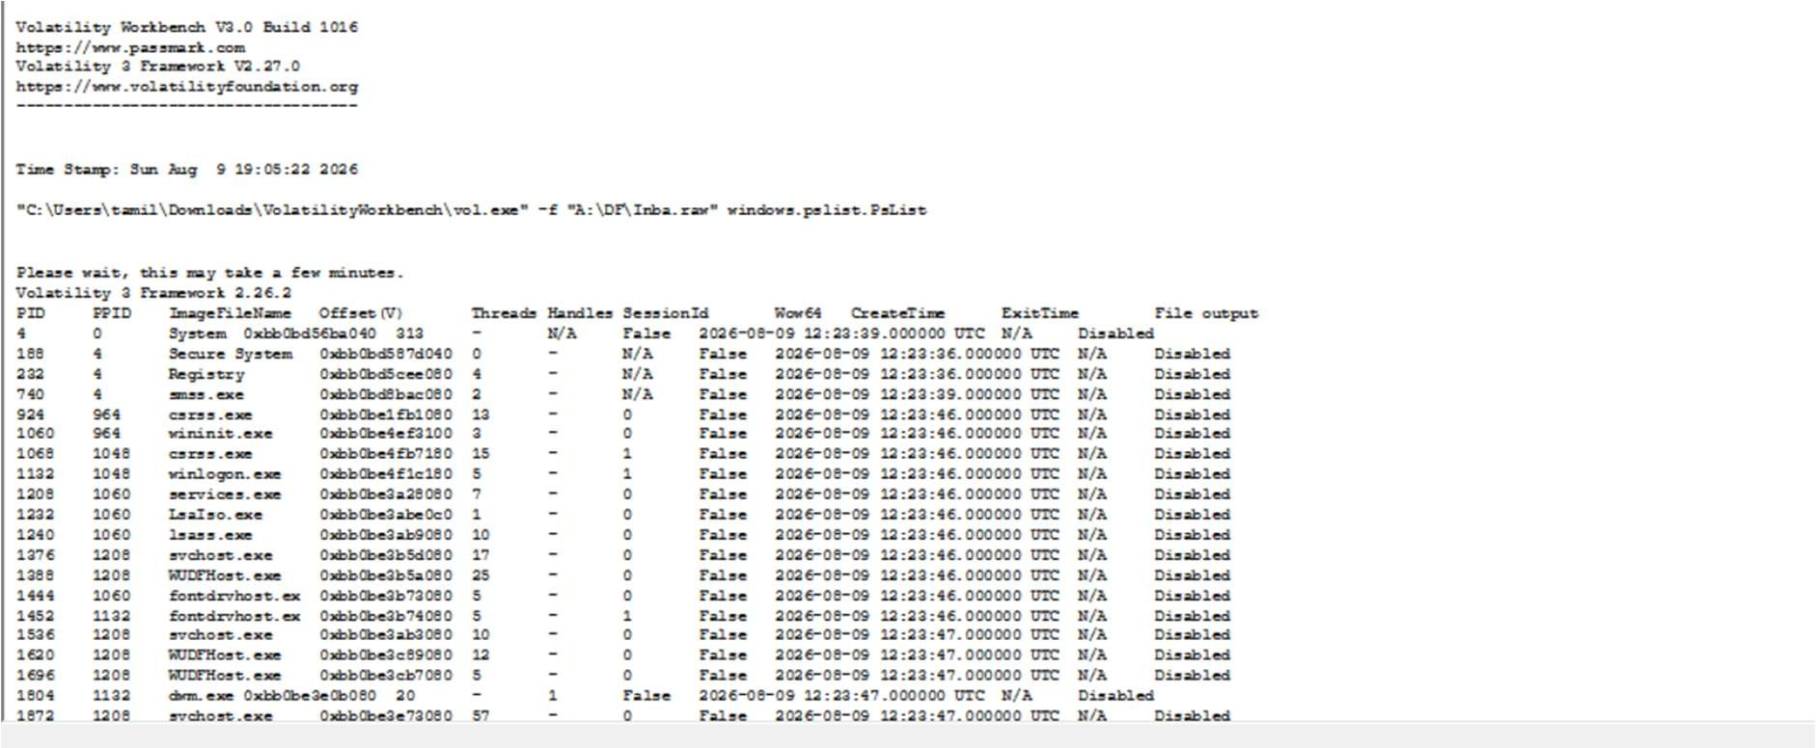
Figure 15: Volatility Workbench execution log displaying the extracted Process List

Note: The log accurately shows winpmem_mini_x (PID 19448) actively running, reflecting the acquisition tool executing at the time of the capture.

RESULT

A complete digital forensics acquisition and analysis workflow was successfully executed via a combination of GUI and CLI tools. The target physical USB drive was securely imaged and verified using FTK Imager. Simultaneously, the system's live RAM was extracted via the Command Prompt using WinPmem. Finally, Volatility 3 command-line syntax was utilized to parse the raw memory file, successfully recovering critical live-state artifacts, including the process list and execution timestamps.

Recover deleted or damaged files from a storage device using TestDisk

EXPERIMENT NO: 02

DATE:

- AIM

To recover deleted files and repair a missing or corrupted partition from a storage device using the TestDisk data recovery command-line utility.

SOFTWARE / TOOLS REQUIRED

  - Operating System: Windows OS

  - Forensics Tool: TestDisk (v7.3-WIP Data Recovery Utility)

  - Hardware: Target Storage Device (e.g., hp v221w 16GB USB Device).

DESCRIPTION

TestDisk is a powerful, open-source data recovery software primarily designed to help recover lost partitions and make non-booting disks bootable again when these symptoms are caused by faulty software, certain types of viruses, or human error (such as accidentally deleting a Partition Table). It can also be utilized to undelete files from FAT, exFAT, NTFS, and ext2 file systems. TestDisk queries the BIOS or the OS in order to find the hard drives and their characteristics, performs a quick check of the disk structure, and looks for lost partitions or deleted files.

PROCEDURE

Step 1: Log Creation & Disk Selection

- Open the testdisk_win.exe application as an Administrator.

- Log Creation: Choose [Create] to instruct TestDisk to create a log file containing technical information and messages. Press Enter to proceed.

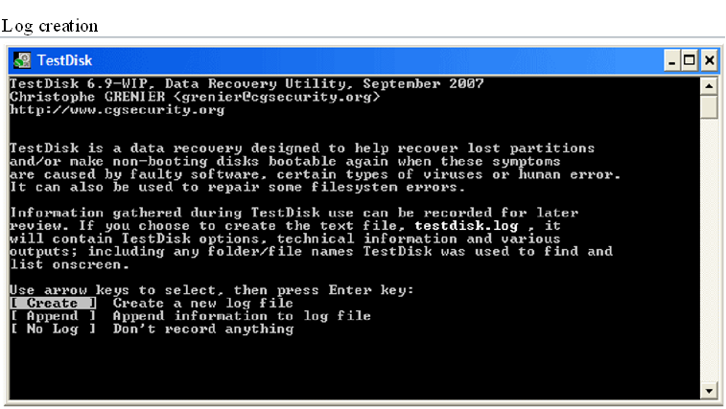
Figure 1: Initial TestDisk dashboard prompting for log creation

- Disk Selection: All connected hard drives will be detected and listed. Use the up/down arrow keys to select the target hard drive containing the lost partitions or deleted files (e.g., Disk \\.\PhysicalDrive1 - 16 GB / 15 GiB - hp v221w). Press Enter to Proceed.
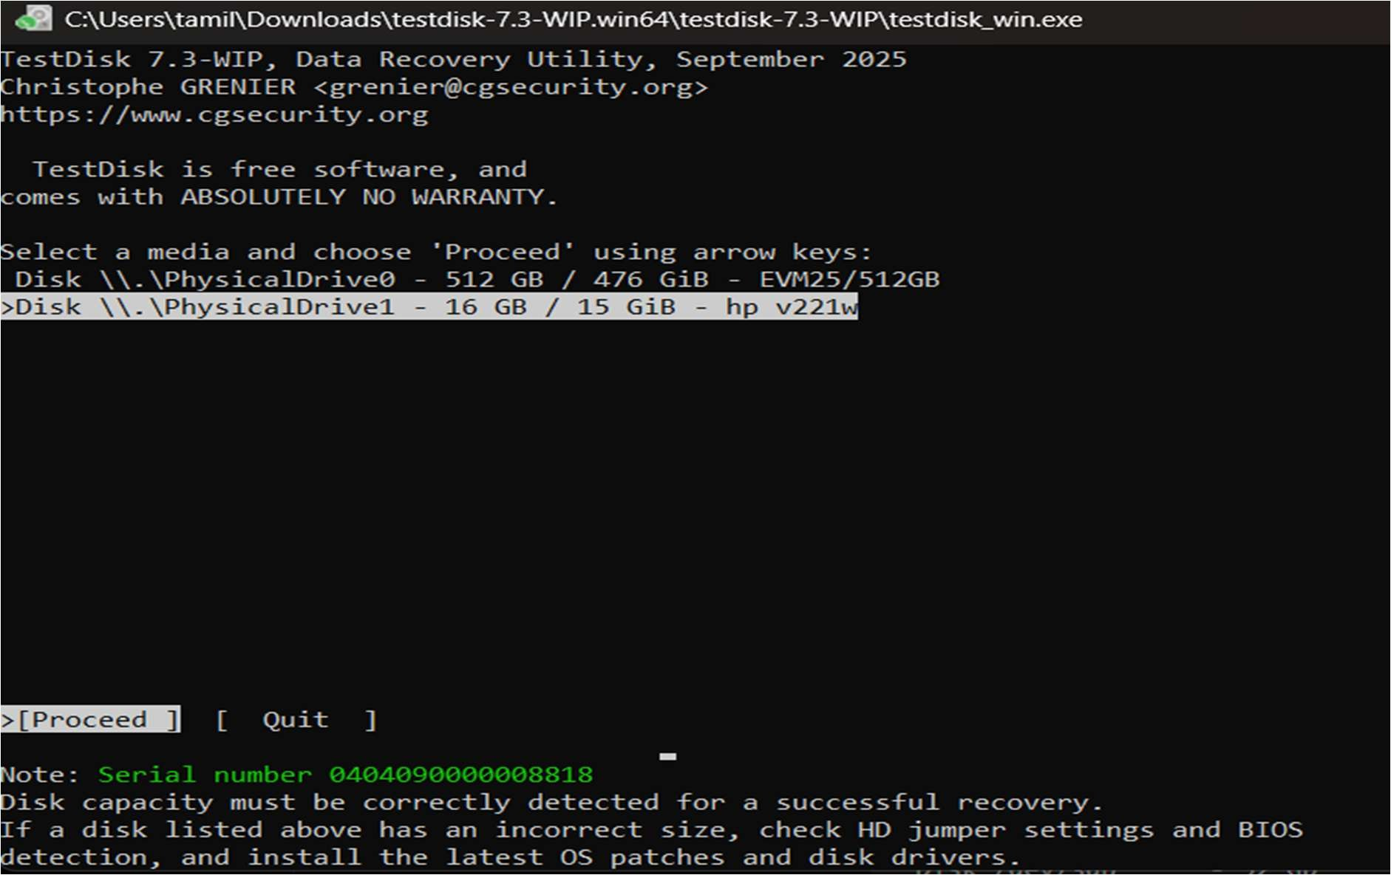
Figure 2: Selecting the physical storage drive in TestDisk

Step 2: Partition Table Type Selection

- TestDisk displays the available partition table types.

- Select the partition table type. Usually, the default value is the correct one as TestDisk auto-detects the partition table type (e.g., [Intel] Intel/PC partition). Press Enter to Proceed.

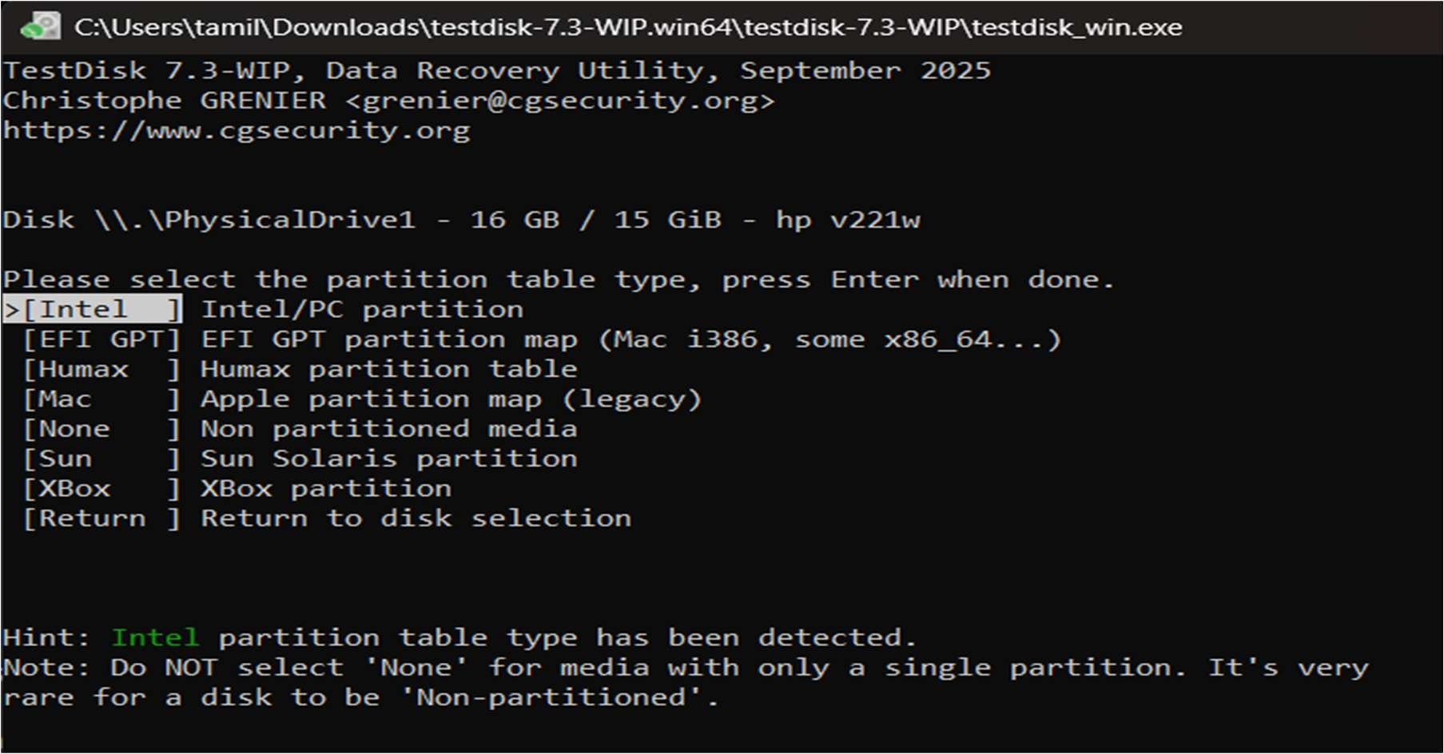
Figure 3: Selecting the Intel/PC partition table type
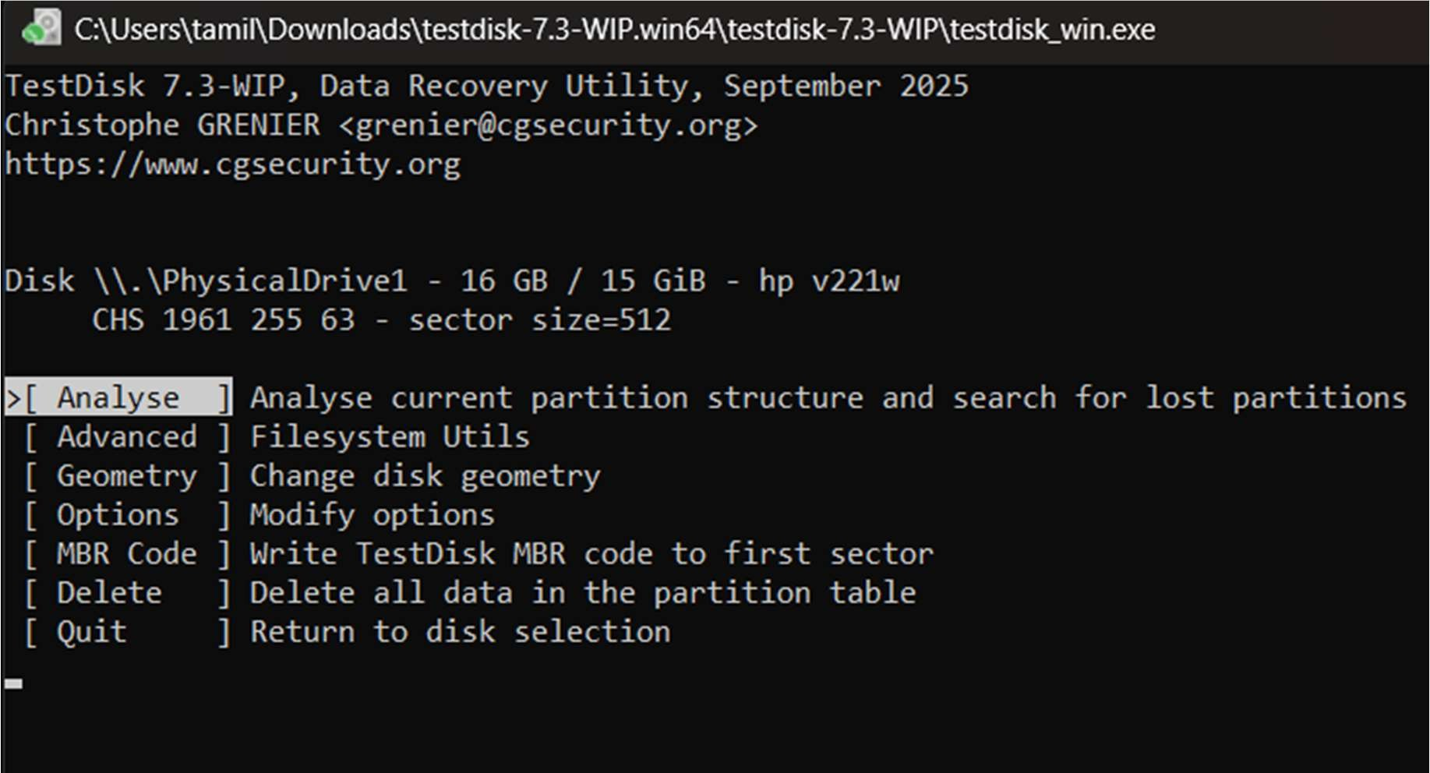
Figure 4: Choosing the Analyse option to examine the partition structure

Step 3: Current Partition Table Status

- TestDisk displays the main menu options. Use the default menu [Analyse] to check your current partition structure and search for lost partitions. Confirm at Analyse with Enter.
- The current partition structure is listed. Examine the structure for missing partitions and errors (e.g., Invalid NTFS boot, missing logical partitions). Confirm at [Quick Search] to proceed.
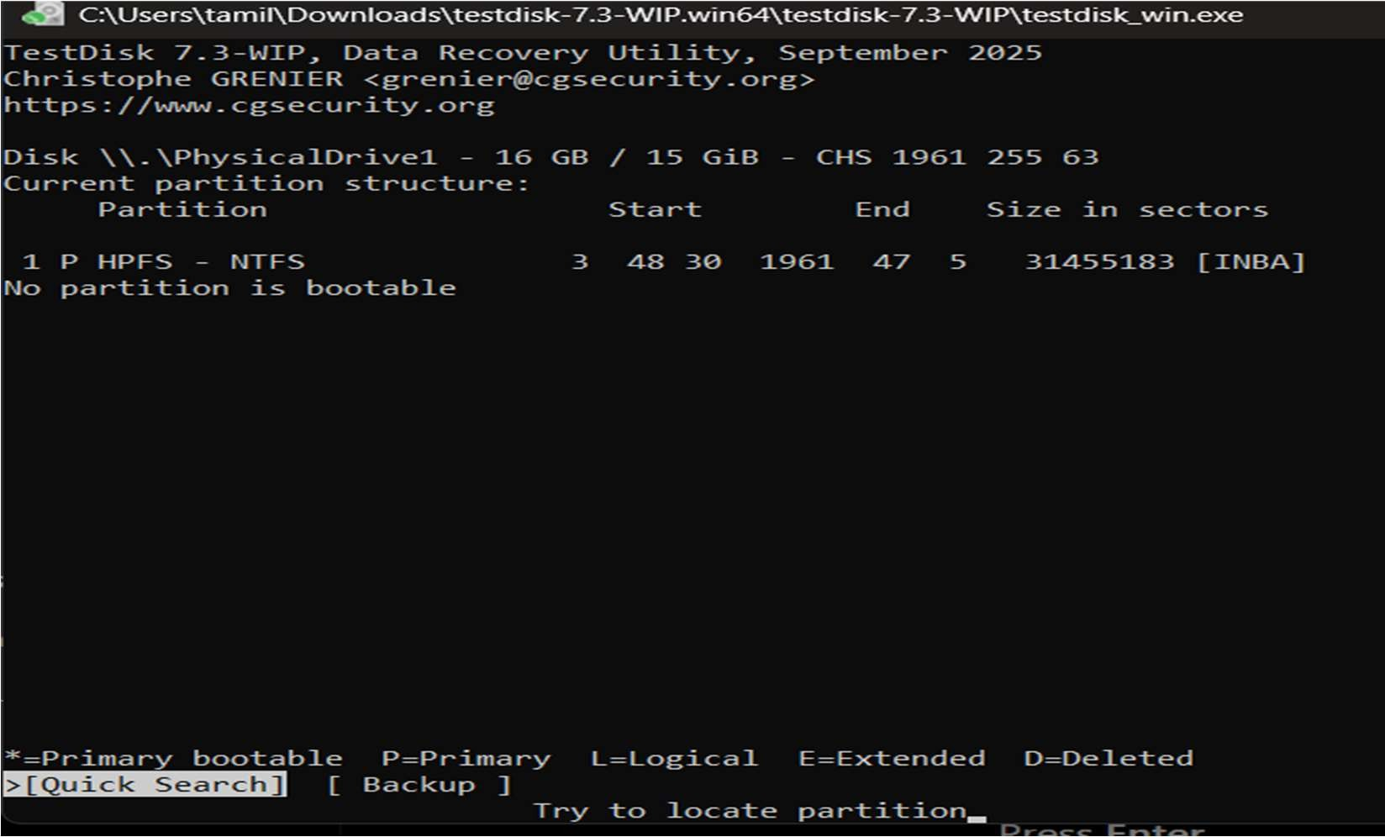

Figure 5: Initiating a Quick Search for lost partitions

Step 4: Deeper Search (If Required)

- If the quick search does not find the required partition or if partitions overlap (status 'D' for deleted), highlight the [Deeper Search] menu and press Enter.
- Deeper Search will scan each cylinder for FAT32 backup boot sectors, NTFS backup boot superblocks, etc., to detect more partitions.
- Review the discovered partitions, change their status if necessary (using the arrow keys), and press Enter to proceed to the next screen.

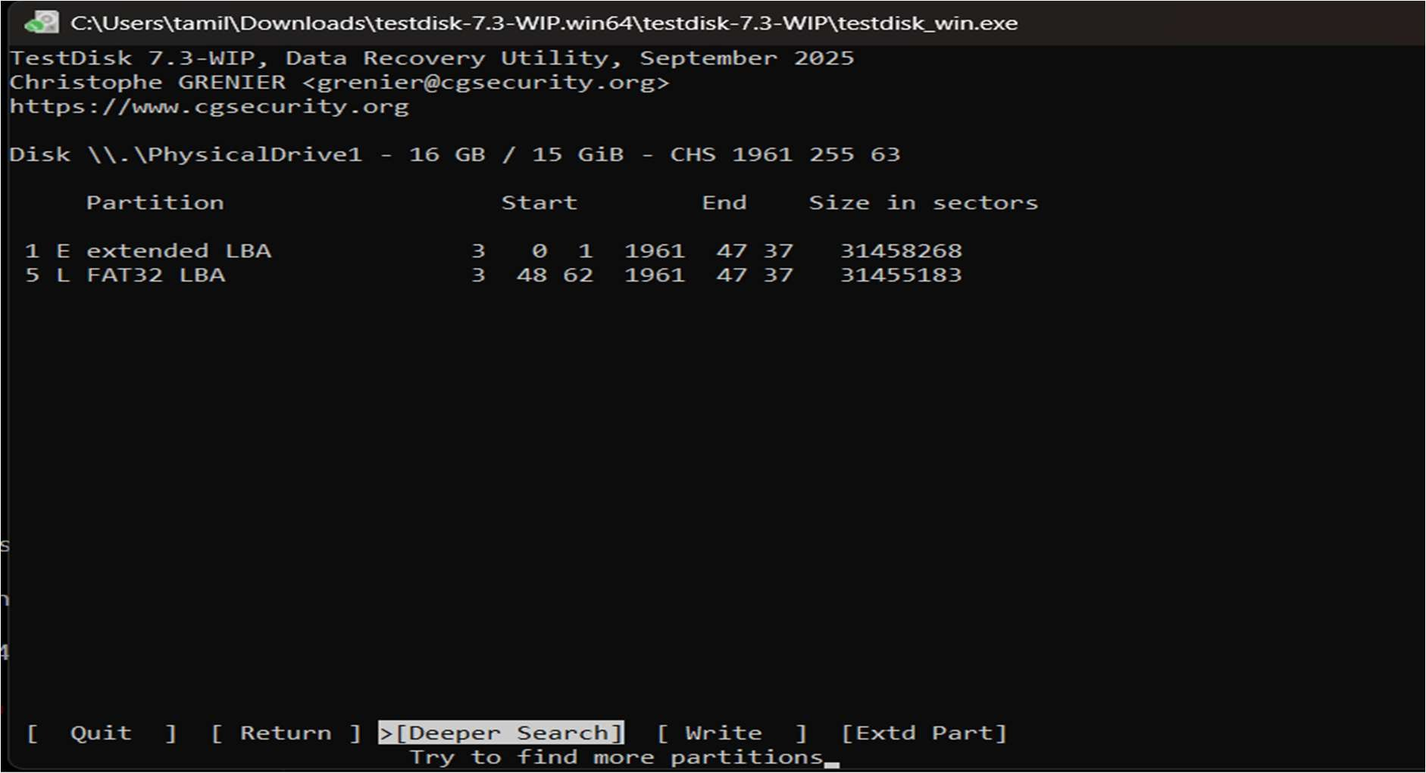
Figure 6: Selecting the Deeper Search option

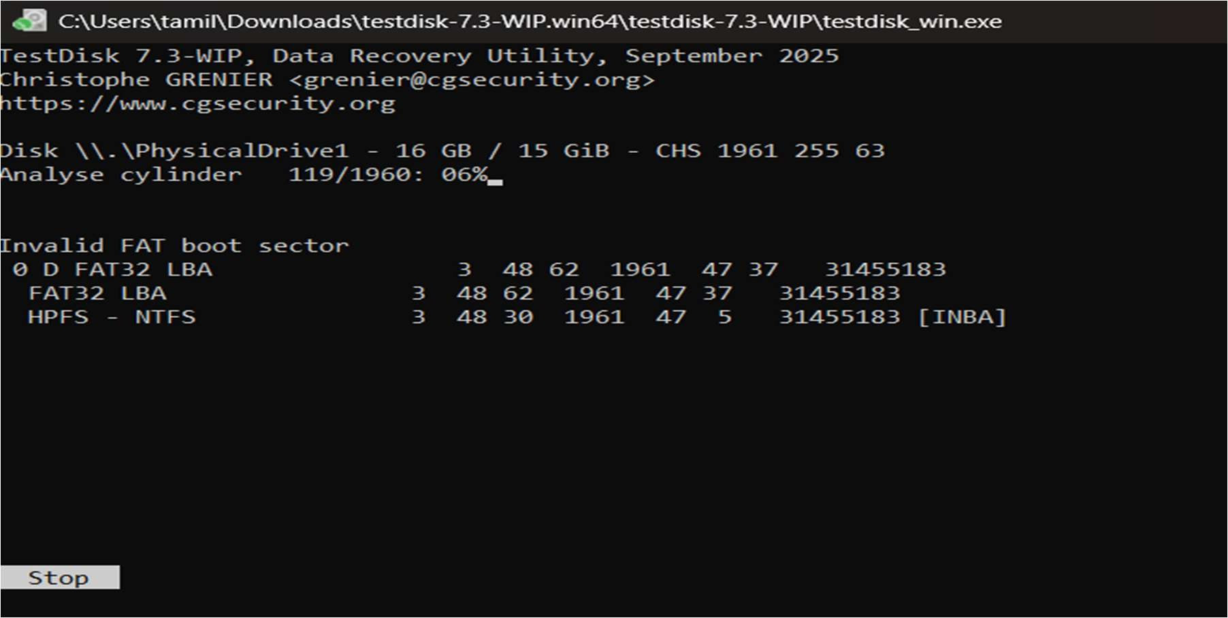
Figure 7: Deeper Search actively scanning disk cylinders

Step 5: Identifying and Accessing the Correct Partition

- Once the search is complete, highlight the correct partition you wish to recover or extract files from (e.g., >L FAT32 LBA).
- Press the p key to list the files inside that partition.

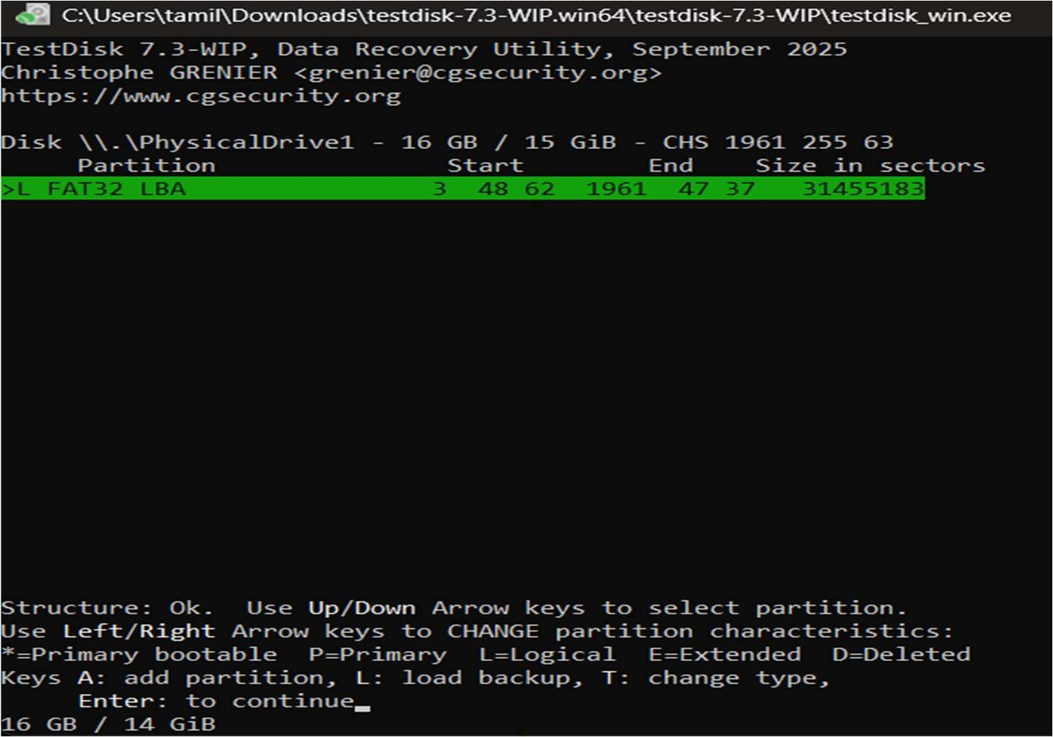

Figure 8: Highlighting the located FAT32 partition
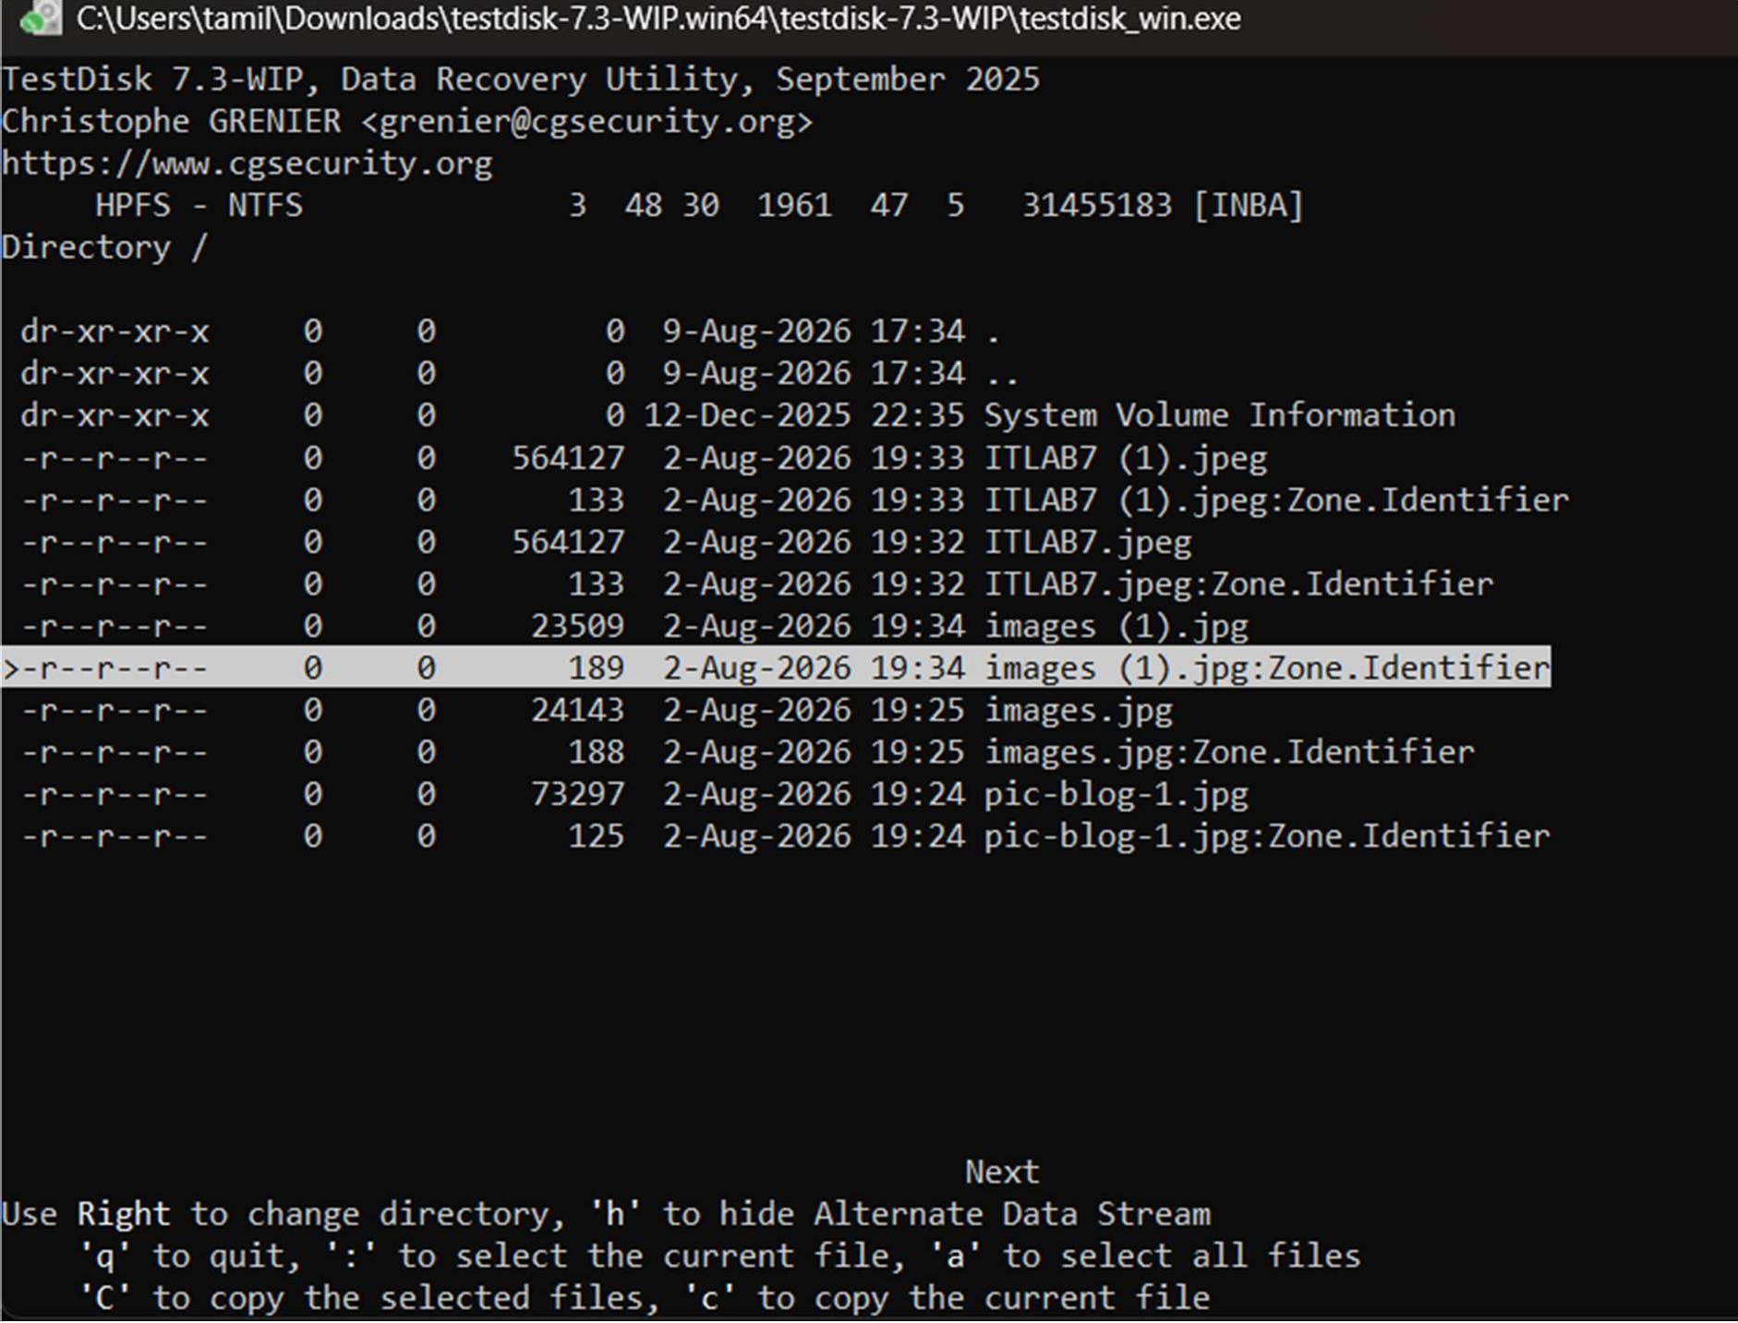
Figure 9: Listing the directory contents and selecting a file for recovery

Step 6: Recovering / Copying Deleted Files

- In the file listing, navigate through the folders using arrow keys. Files listed in red indicate deleted entries.
- Highlight the specific deleted file you want to recover (e.g., images (1).jpg).

- Press c to copy the current selected file (or C to copy all selected files).

- You will be prompted to select a destination directory to save the recovered file. Navigate to the desired local folder and press C when the destination is correct.
- TestDisk will display a confirmation message indicating a successful recovery (e.g., "Copy done! 1 ok, 0 failed").

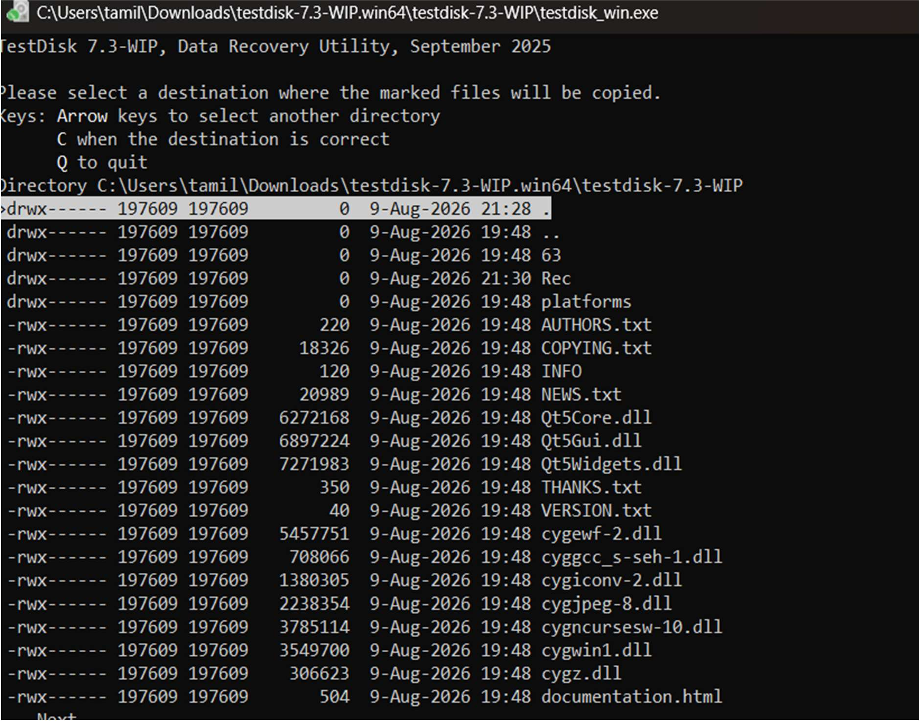
Figure 10: Selecting the destination folder for the recovered file

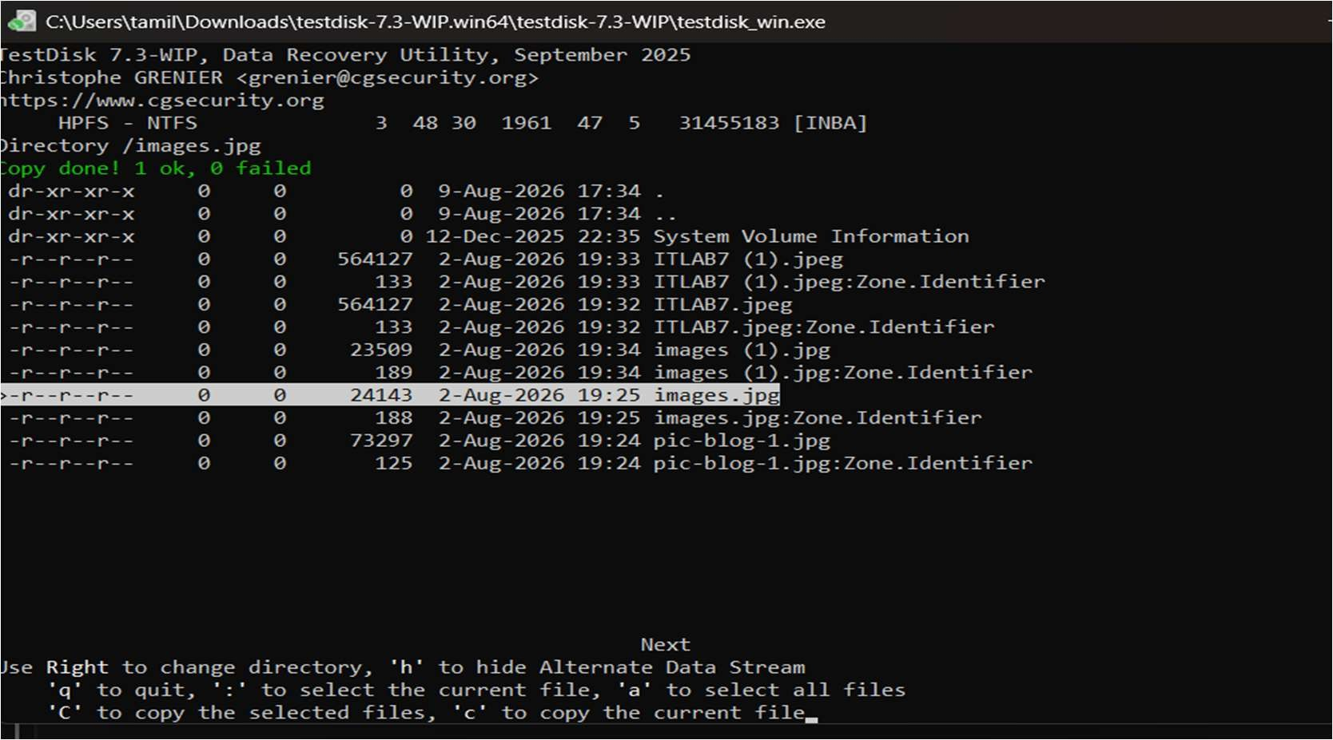
Figure 11: Successful copy/recovery of the deleted file

Step 7: Partition Table and Boot Sector Recovery (Optional)

- Press q to quit the file listing and return to the partition selection.

- Use the left/right arrow keys to change the status of a partition from D (Deleted) to L (Logical) or P (Primary) to recover the partition itself. Press Enter.
- If all partitions are correctly listed, confirm at [Write] with Enter, press y to confirm, and then OK.
- If a boot sector is damaged, use the [Backup BS] option to copy the backup boot sector over the damaged one.
- Exit TestDisk and reboot the computer to access the restored partition data.

RESULT

The TestDisk data recovery utility was successfully executed to analyze the physical drive's geometry and partition tables. Lost partitions were successfully identified through deeper searching, and deleted files were effectively navigated, selected, and copied (recovered) to a secure local destination.

Network Packet Sniffing and Credential Analysis Using Wireshark

EXPERIMENT NO: 03

DATE:

- AIM

To capture and analyze unencrypted network traffic using the Wireshark packet analyzer, isolate HTTP GET and POST request methods, and extract transmitted plain-text login credentials (username and password).

SOFTWARE / TOOLS REQUIRED

  - Operating System: Windows 10/11 or Kali Linux

  - Packet Analyzer: Wireshark v4.x (with Npcap driver installed)

  - Web Browser: Google Chrome / Mozilla Firefox

  - Target Environment: Acunetix Web Vulnerability Test Site ([http://testphp.vulnweb.com](http://testphp.vulnweb.com))

DESCRIPTION

Network packet sniffing is the process of monitoring and capturing data packets passing through a network interface card (NIC). Wireshark utilizes packet capture drivers (Npcap/libpcap) to set the system's NIC into promiscuous mode, allowing it to capture all frames traversing the local network segment.
When web applications transmit data using unencrypted protocols such as HTTP (Hypertext Transfer Protocol) over TCP port 80, the payload remains in ASCII plain text:
  - HTTP GET Method: Appends parameters to the URL string. While used primarily for retrieving data, it leaves information visible in server logs and browser histories.
  - HTTP POST Method: Embeds data within the body of the request header (Content-Type: application/x-www-form-urlencoded). Although hidden from the URL bar, the payload remains completely legible to network sniffers if not protected by TLS/SSL encryption (HTTPS).

PROCEDURE

Step 1: Interface Initialization

- Launch Wireshark.

- Select the active Wi-Fi network interface to begin live traffic capture.
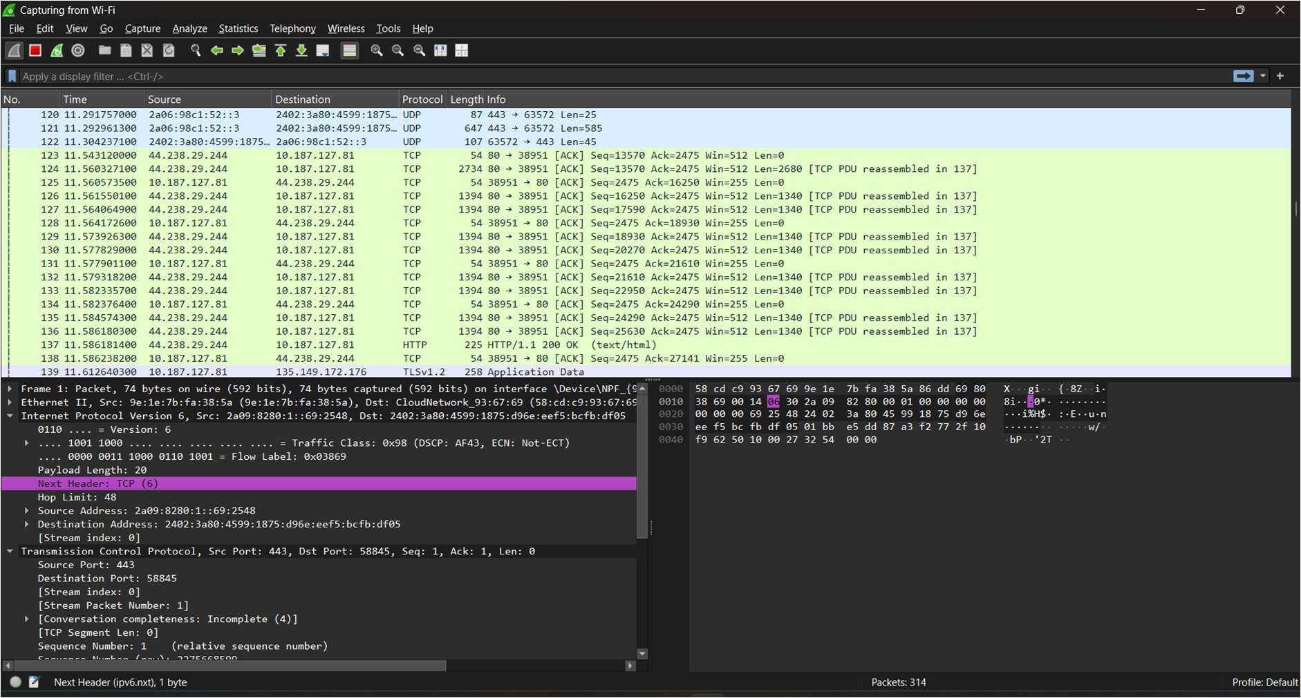
Figure 1: Wireshark Interface Capture Selection

Step 2: Generating Network Traffic

- Open the target web page in a browser.

- Enter the credential details (Username: 9240040009, Password: Abinesh) into the form fields and submit.
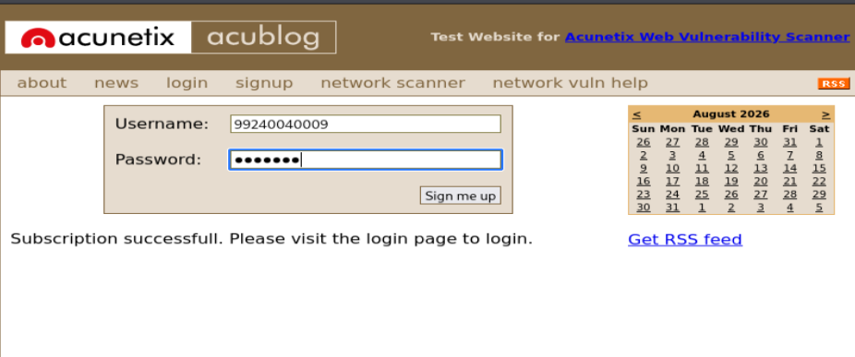
Figure 2: Submitting Credentials on Test Web Page

Step 3: Filtering Protocol Traffic

Apply the http filter in the display filter bar to filter out ambient TCP, UDP, and DNS background traffic and isolate application-layer HTTP traffic.
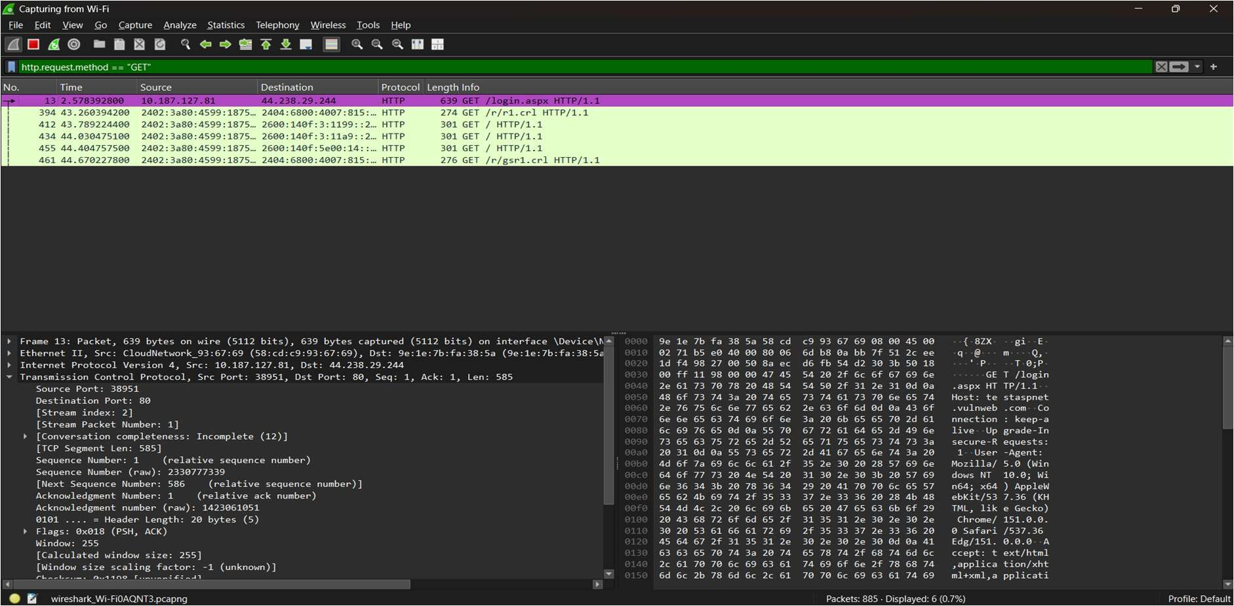
Figure 3: Applying Display Filter for HTTP Protocol

Step 4: Inspecting HTTP GET Requests

Enter the following filter to inspect GET requests:

http.request.method == "GET"

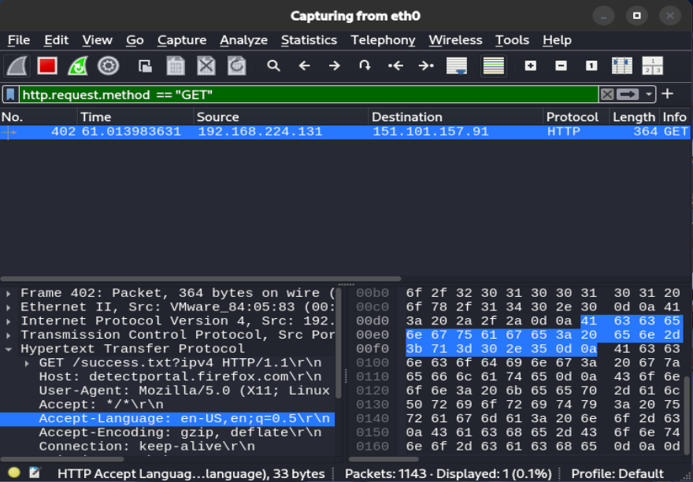
Observation: GET packets retrieve page components (/login.aspx), but do not carry submitted form parameters in their payload.

Figure 4: Analysis of Captured HTTP GET Requests

Step 5: Extracting POST Payload and Credentials Apply the POST filter to locate form submission requests: http.request.method == "POST"
Select the packet containing application/x-www-form-urlencoded. In the Packet Details pane, expand the HTML Form URL Encoded tree to read the plain-text form variables.
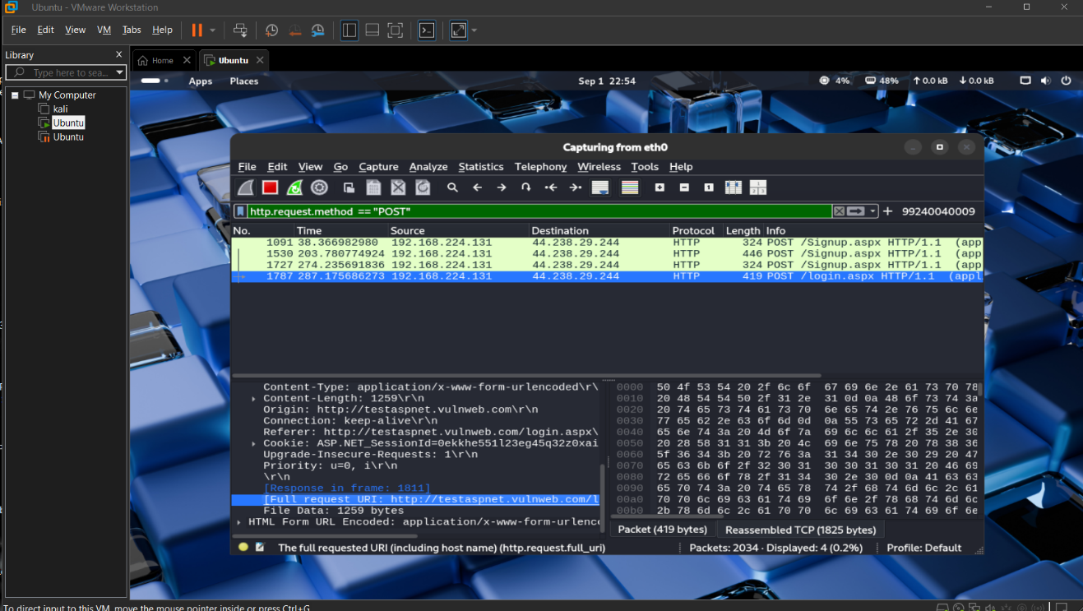
Figure 5: Inspecting HTTP POST Packet Payload

OBSERVATIONS

Extracted Form Parameters

Field Name | Captured Key | Extracted Value
Username | tbUsername | 9240040009
Password | pass / tbPassword | Abinesh

VERIFICATION OF SAVED LOGS & DIRECTORY STRUCTURE

The packet capture data (Captured_File.pcapng) and generated screen outputs have been archived in the repository.

PREVENTIVE COUNTERMEASURES

- Enforce HTTPS (TLS 1.3): Encrypt all client-server communications so intercepted payloads appear as encrypted ciphertext.
- HTTP Strict Transport Security (HSTS): Enforce browser-side HSTS policies to prevent downgrade attacks to plain HTTP.
- Network Isolation: Implement VLANs and 802.1X port-based access controls to restrict unauthorized packet sniffing on local physical and wireless networks.

RESULT

The network traffic was successfully captured and analyzed using Wireshark. Plain-text credentials (Username: 9240040009, Password: Abinesh) transmitted over HTTP were extracted from the POST request payload.

Analyze Email Headers and Detect Email Spoofing using MHA (Mail Header Analyzer)
EXPERIMENT NO: 04

DATE:

- AIM

To extract, analyze, and interpret email headers to trace an email's origin, verify its authenticity protocols (SPF, DKIM, DMARC), and detect potential spoofing or phishing attempts using Mail Header Analyzer (MHA) tools.

SOFTWARE / TOOLS REQUIRED

  - Operating System: Windows, Linux, or macOS

  - Email Client: Web browser accessing Gmail, Outlook, or Yahoo

  - Analysis Tools: MXToolbox (Online Mail Header Analyzer), WHOIS IP Lookup

DESCRIPTION

Every email sent over the internet contains hidden metadata known as an Email Header. This header tracks the email's journey from the sender's server to the recipient's inbox and contains critical routing and authentication information. Analyzing these headers helps forensic investigators verify if an email is legitimate or spoofed.
Key Authentication Protocols:

  - SPF (Sender Policy Framework): Checks if the sender's IP address is authorized to send emails on behalf of the claimed domain.
  - DKIM (DomainKeys Identified Mail): A cryptographic signature that verifies the email content has not been altered in transit.
  - DMARC (Domain-based Message Authentication, Reporting, and Conformance): A policy that uses both SPF and DKIM to authenticate the email and instruct the receiving server on how to handle failures.

PROCEDURE & OBSERVATIONS

Step 1: Accessing the Suspicious Email

- Log into your email account (e.g., Gmail) and locate the target email you wish to investigate (often found in the Spam or Inbox folder).
- Open the email to view the sender details and subject line.

Figure 1: Viewing the suspicious email in the Gmail Spam folder

Step 2: Extracting the Raw Email Header

- To view the hidden metadata in Gmail, click the three dots (More) in the upper right corner of the email and select "Show original". (For Outlook: File > Properties > Internet headers. For Yahoo: More > View raw message).
- Copy all the raw text provided. This text contains the Received fields, Message-ID, and authentication results.
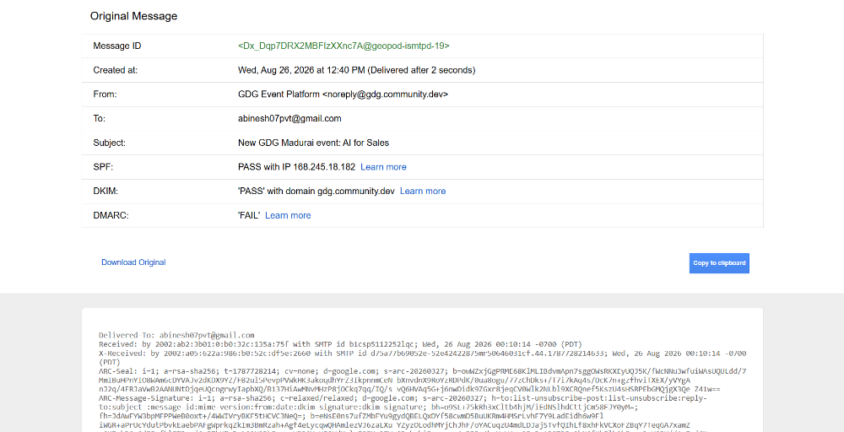
Figure 2: Extracting the original raw message and email header data

Step 3: Analyzing the Header via MXToolbox

- Navigate to an online Mail Header Analyzer, such as MXToolbox.

- Paste the copied raw header text into the analysis tool and click Analyze.

- Review the Delivery Information and Relay Information to trace the chronological path (hops) the email took from the sending server to the receiving server. Check for unusual delays or suspicious routing.
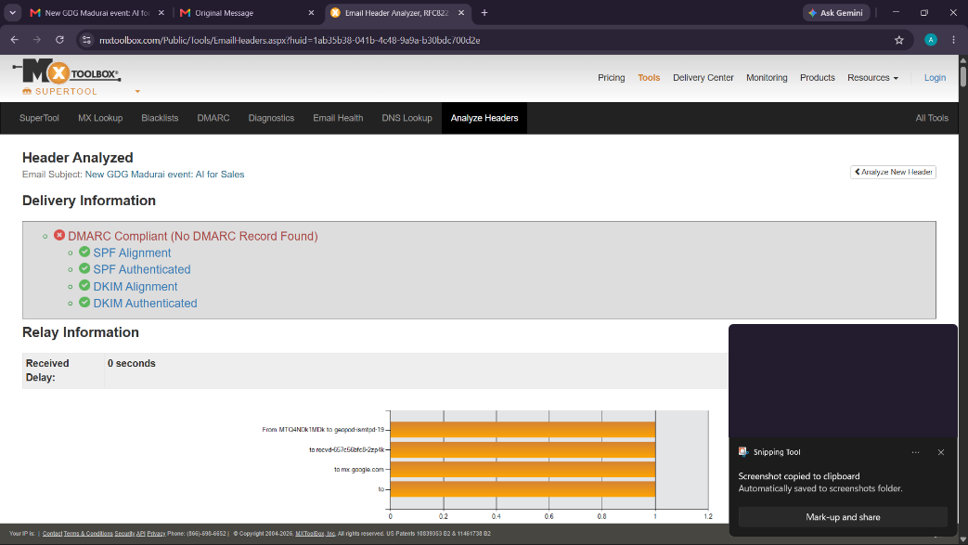
Figure 3: MHA relay analysis showing chronological hops and delivery delays

Step 4: Examining SPF, DKIM, and DMARC Results

- Scroll down in the analyzer tool to inspect the authentication policies and Verify if the DMARC record is compliant.
- Check the SPF and DKIM alignment to ensure the sender's IP (185.255.8.37) was genuinely authorized by the domain (communication.vodafoneidea.in).
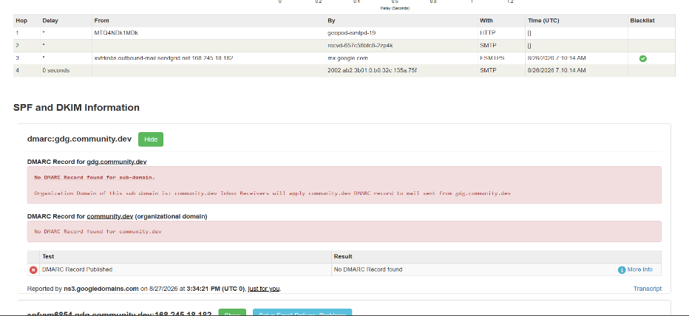
Figure 4: Verification of SPF, DKIM, and DMARC cryptographic records

Step 5: IP Address and Hostname Verification

- Extract the primary sending IP address identified in the Received lines (185.255.8.37).

- Use a WHOIS lookup tool to identify the geographical location and ownership of the IP address.
- Determine if the registered organization matches the expected sender.
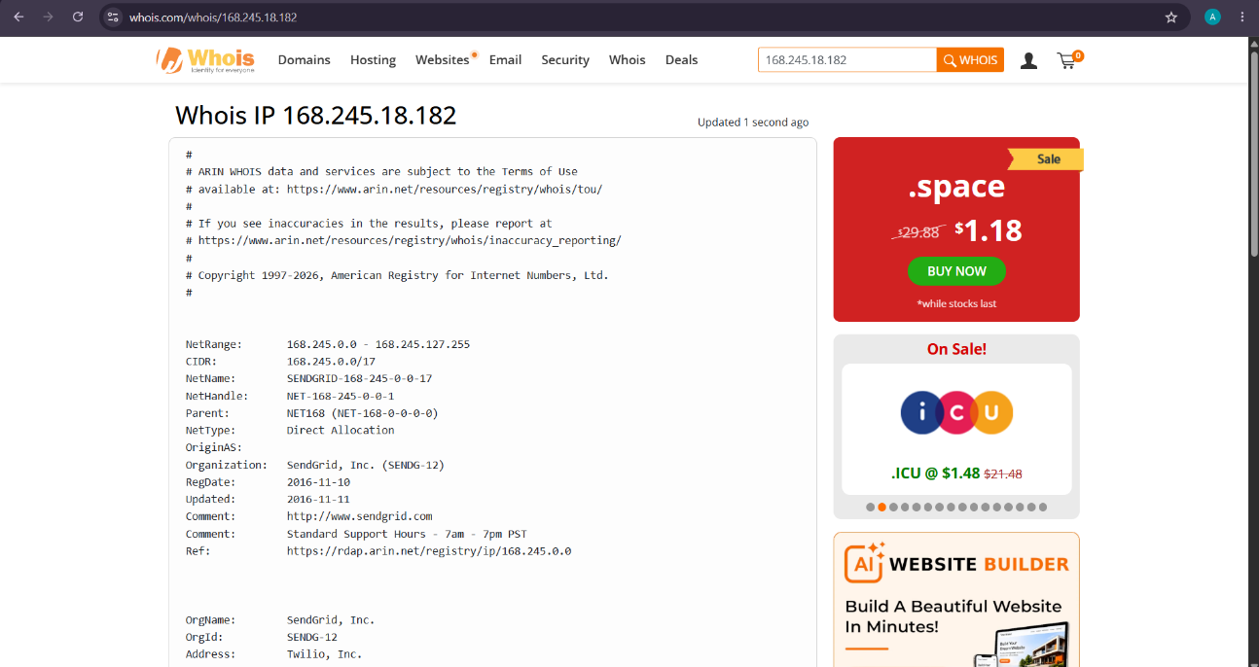
Figure 5: WHOIS IP lookup revealing the hosting organization (INFOBIP_INDIA)

- FORENSIC FINDINGS & ANALYSIS

Based on the header analysis conducted:

- Sender Domain: communication.vodafoneidea.in
- Sending IP Address: 168.245.18.182
- Authentication Status: The email PASSED all primary checks (SPF, DKIM, and DMARC). The IP address is officially authorized to send on behalf of the domain.
- WHOIS Verification: The IP belongs to INFOBIP_INDIA, a legitimate bulk SMS and email gateway service frequently used by telecom providers.

- Hop-by-Hop Routing Analysis: An examination of the chronological Received: lines reveals a logical network path from the originating server to Google’s MTAs, with no forged intermediate hops.
- Timestamp and Latency Verification: The timestamps at each server handoff indicate normal transit times, showing no suspicious network delays or rerouting.
- Message-ID Integrity: The Message-ID string follows the standard format expected from an enterprise mail server, ruling out the use of generic spam scripts.
- Return-Path Alignment: The Return-Path address correctly aligns with the sender's infrastructure, typical of legitimate bulk senders.
- X-Header & Spam Assessment: Custom X-Headers indicate that the email triggered spam filters due to promotional content heuristics, not because of a security protocol failure.
- Conclusion on Spoofing: Despite being flagged as spam by Gmail's automated content filters (likely due to promotional marketing content), the complete header analysis proves this email is cryptographically authentic and not spoofed. The sender identity is genuine.

RESULT

The email header was successfully extracted and analyzed using MXToolbox. Authentication protocols (SPF, DKIM, DMARC) and the originating IP address were manually verified, demonstrating how to trace email origins and detect potential spoofing.

Digital Forensics Investigation Using Autopsy: Case Creation and Evidence Import
EXPERIMENT NO: 05

DATE:

- AIM

To use the Autopsy digital forensics platform to create a new forensic case, import digital evidence (disk image files), configure ingest modules, and perform basic forensic analysis and reporting.

SOFTWARE / TOOLS REQUIRED

  - Operating System: Windows, Linux, or macOS

  - Forensics Tool: Autopsy Digital Forensics Platform

  - Evidence Files: Disk image files (4Dell Latitude CPi.E01, 4Dell Latitude CPi.E02) downloaded from the provided forensic repository.

DESCRIPTION

Autopsy is a premier open-source digital forensics platform and graphical interface to The Sleuth Kit and other digital forensics tools. It is widely used by law enforcement, military, and corporate examiners to analyze and extract critical data from digital devices.
In a standard forensic investigation, raw data or disk images (such as .E01, .dd, or .raw formats) are imported into a securely managed "Case". Autopsy utilizes various Ingest Modules (like File Type Identification, Keyword Searching, Timeline Analysis, and Hash Lookups) to process this evidence in the background, automatically categorizing artifacts such as web history, file system metadata, and communication records for the examiner to review. Autopsy is the premier end-to-end open source digital forensics platform. Built by Sleuth Kit Labs with the core features you expect in commercial forensic tools, Autopsy is a fast, thorough, and efficient hard drive investigation solution that evolves with your needs.

PROCEDURE

Step 1: Installation & Preparation

- Download and install the Autopsy application based on the host operating system.

- Download the required evidence files (4Dell Latitude CPi.E01) to a secure local directory.
- Launch the Autopsy application to view the welcome screen.

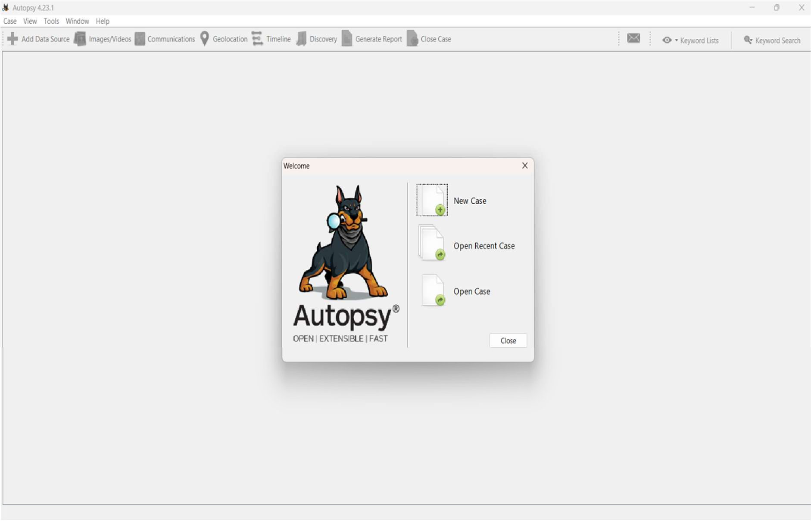
Figure 1: Autopsy startup menu and tool interface

Step 2: Starting a New Case

- Click on New Case from the startup menu.

- Enter the case name (e.g., Abi_Investgation) and specify the base directory where the case data will be stored.
- Click Next to proceed to the optional information.

- Fill in the required case details, including the case number and examiner's name (Abinesh S), then click Finish.
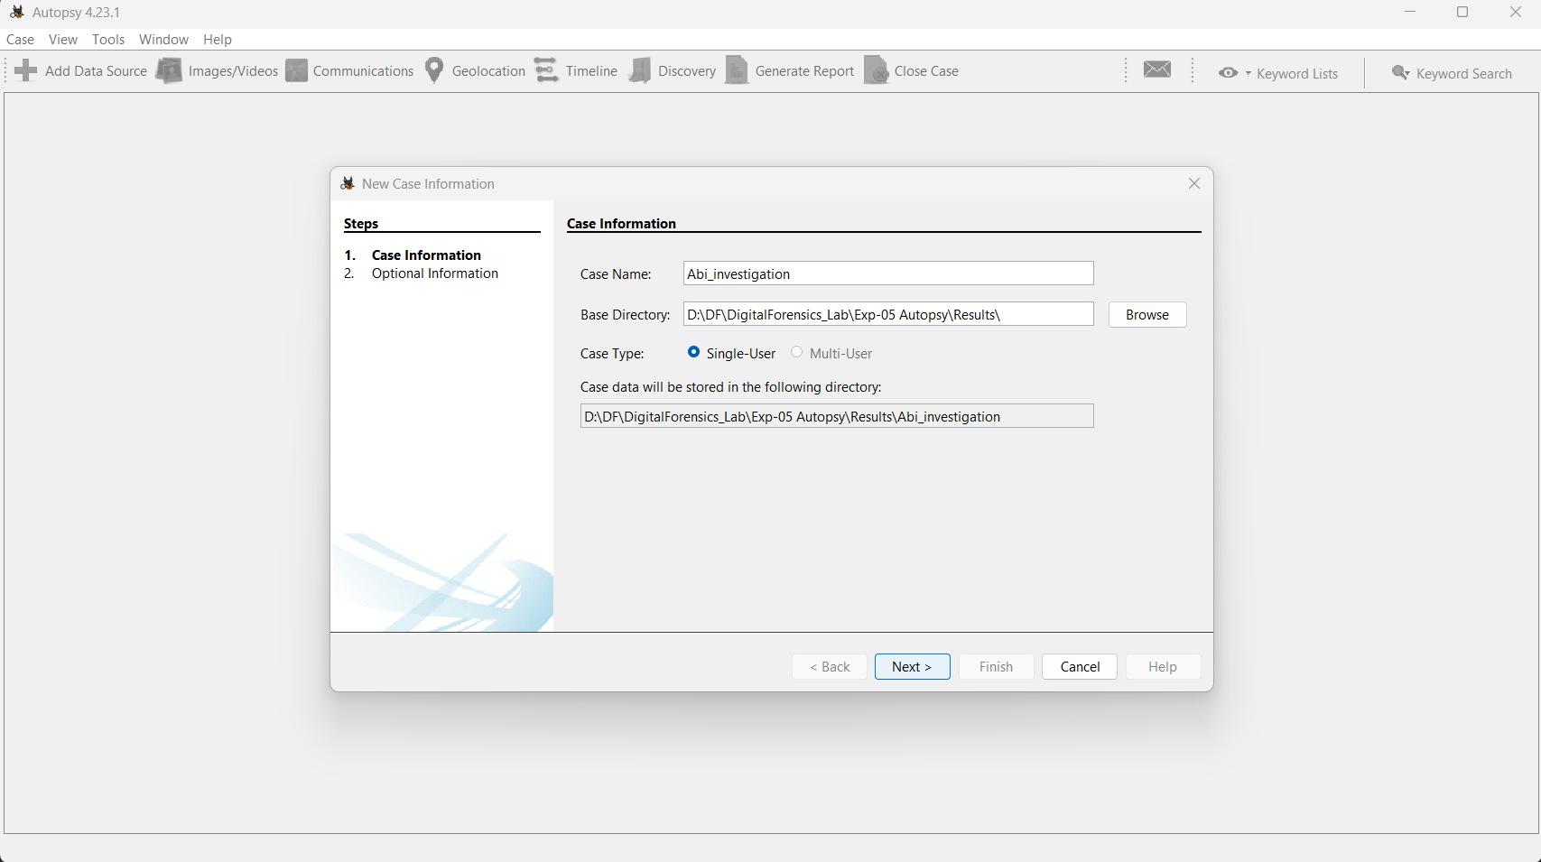
Figure 2: Creating a new forensic case and setting the base directory

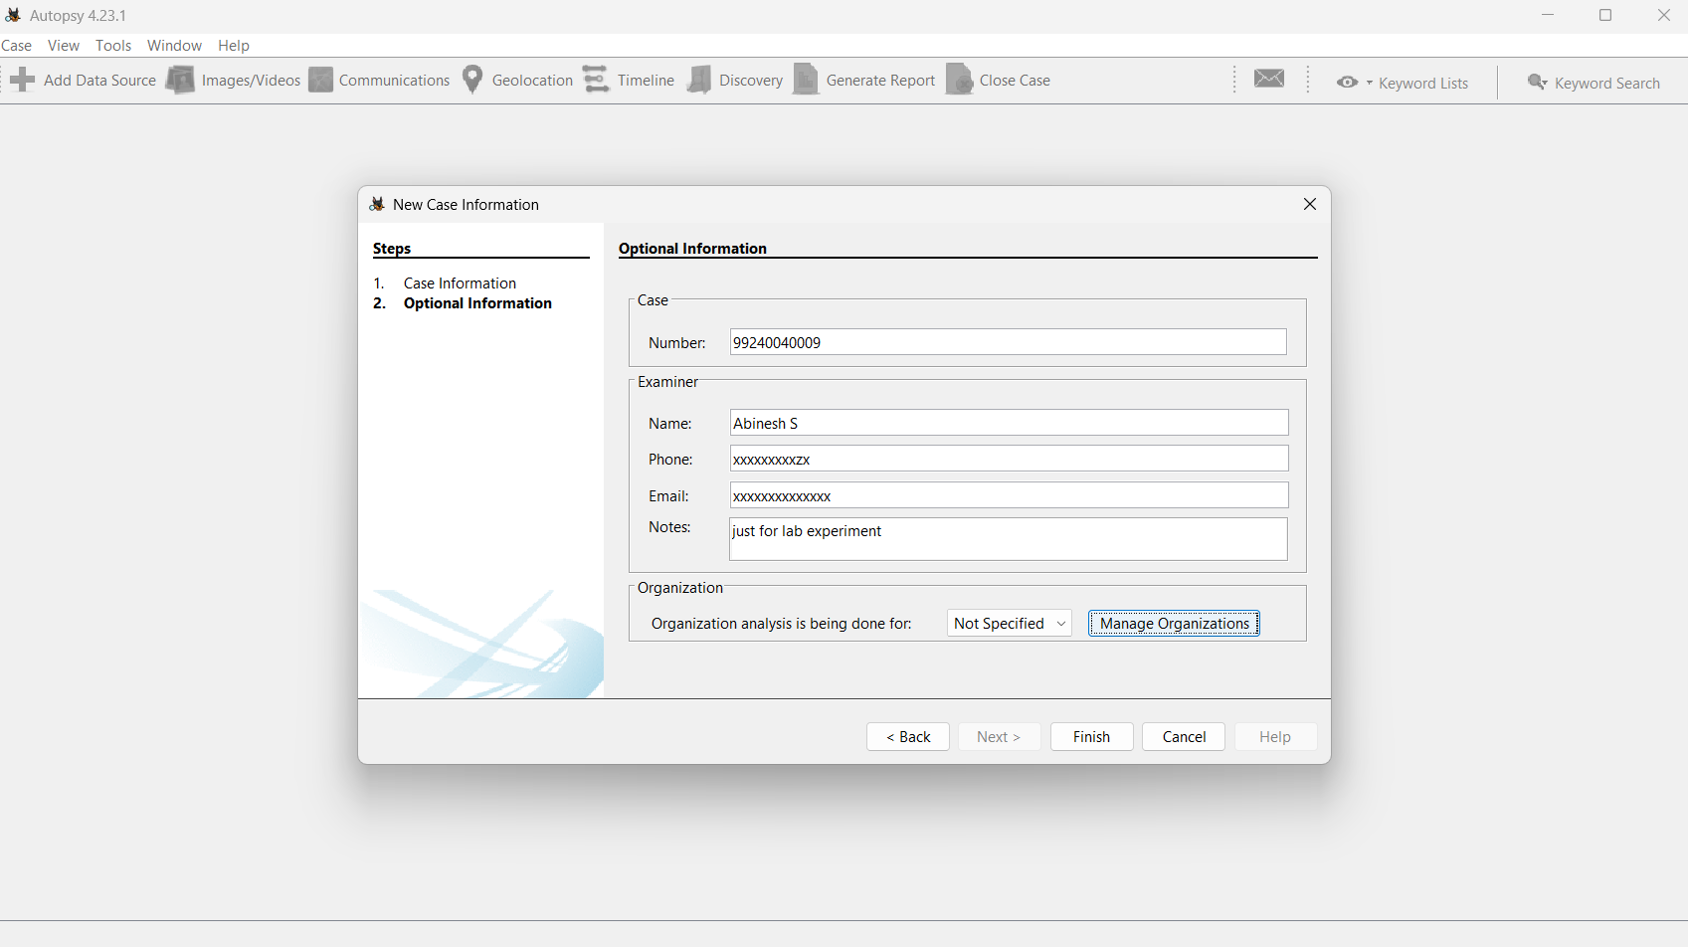

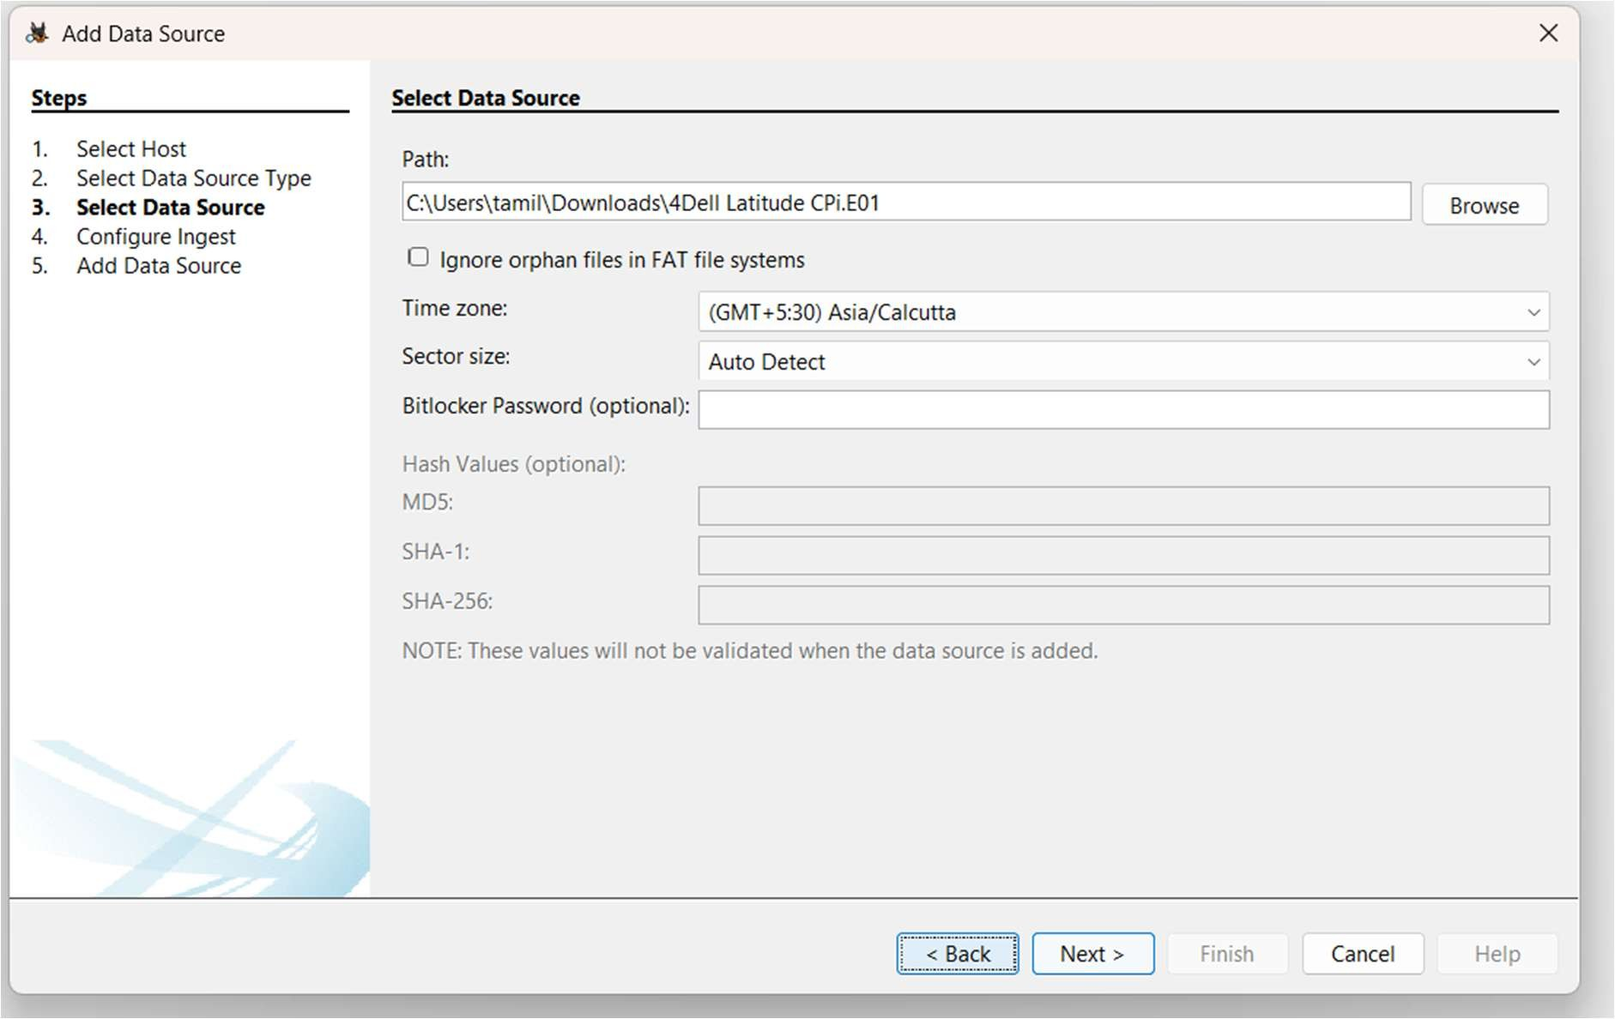

Step 3: Adding a Data Source

- When prompted to add a data source, choose the type of data source (e.g., Disk Image or VM file).
- Browse to the local directory and select the downloaded evidence file (4Dell Latitude CPi.E01).
- Configure Ingest Modules: Select the specific analysis modules required for the investigation.
- Click Next to start the analysis.

Figure 3: Entering Optional Information including Examiner detail

Figure 4: Importing the .E01 evidence file data source

Step 4: Initial Analysis and Overview

- Monitor the Ingest Progress in the lower-left corner of the interface as Autopsy processes the data source.
- Once processing yields results, use the Tree Viewer on the left pane to explore different categorized aspects like File System, Deleted Files, Data Artifacts, etc.

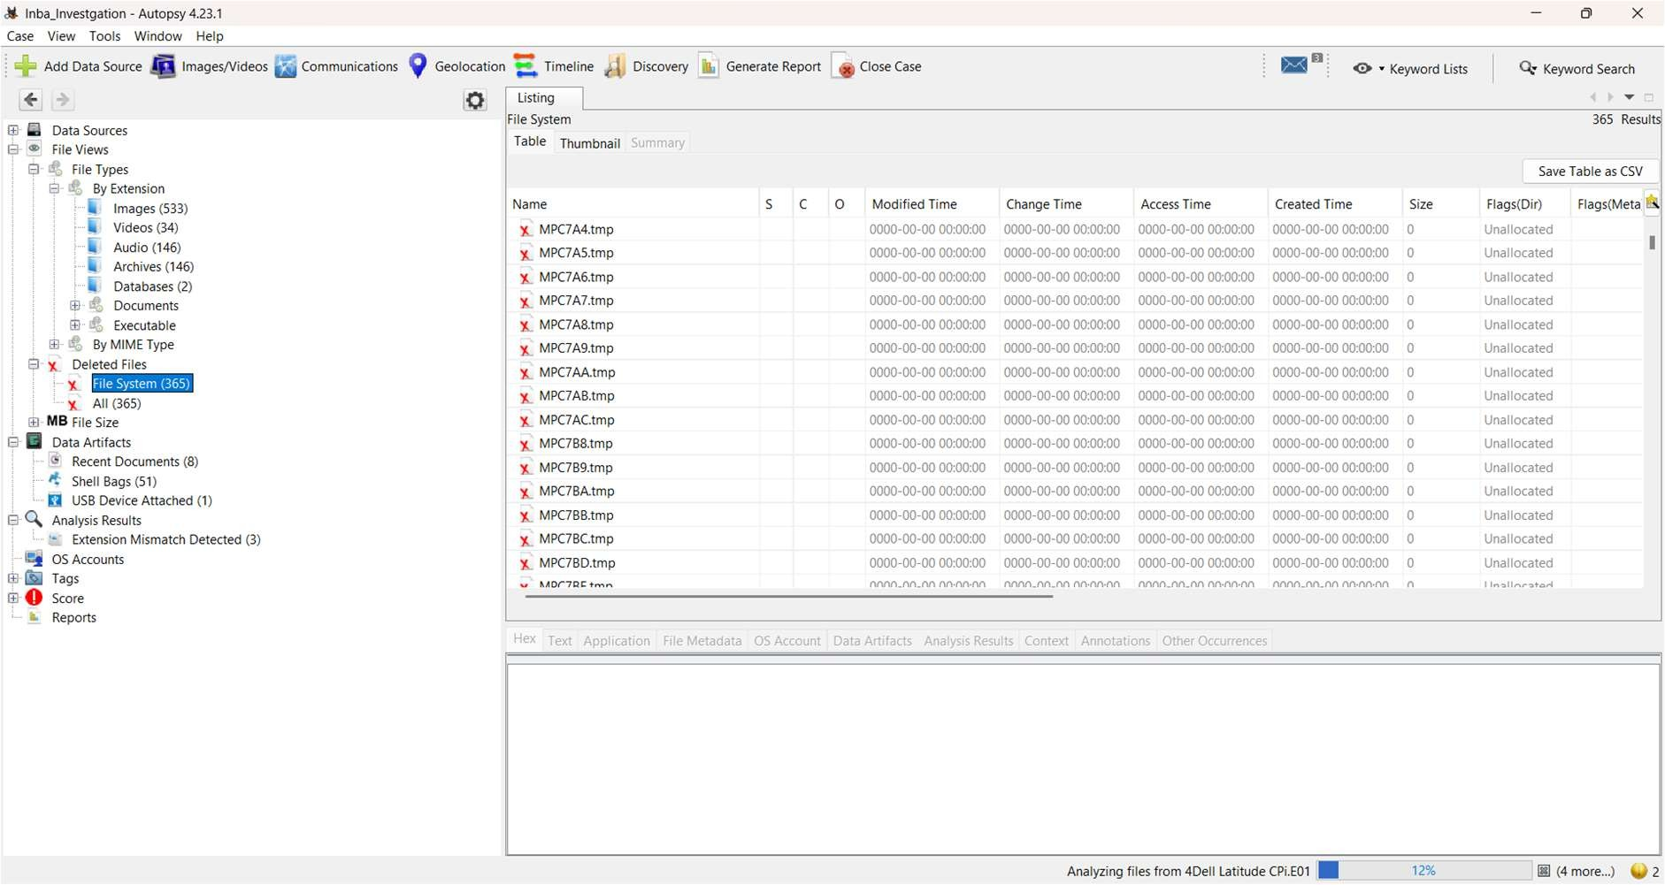
Figure 5: Exploring categorized forensic artifacts and deleted files in the Tree Viewer

Step 5: Detailed Analysis

- File Analysis: Navigate through files and folders under the File Types or File System section. Open, view, or extract files for further examination.
- Select an individual file (e.g., audio files under the Audio category) to view its hex, text, application, or file metadata in the lower pane.
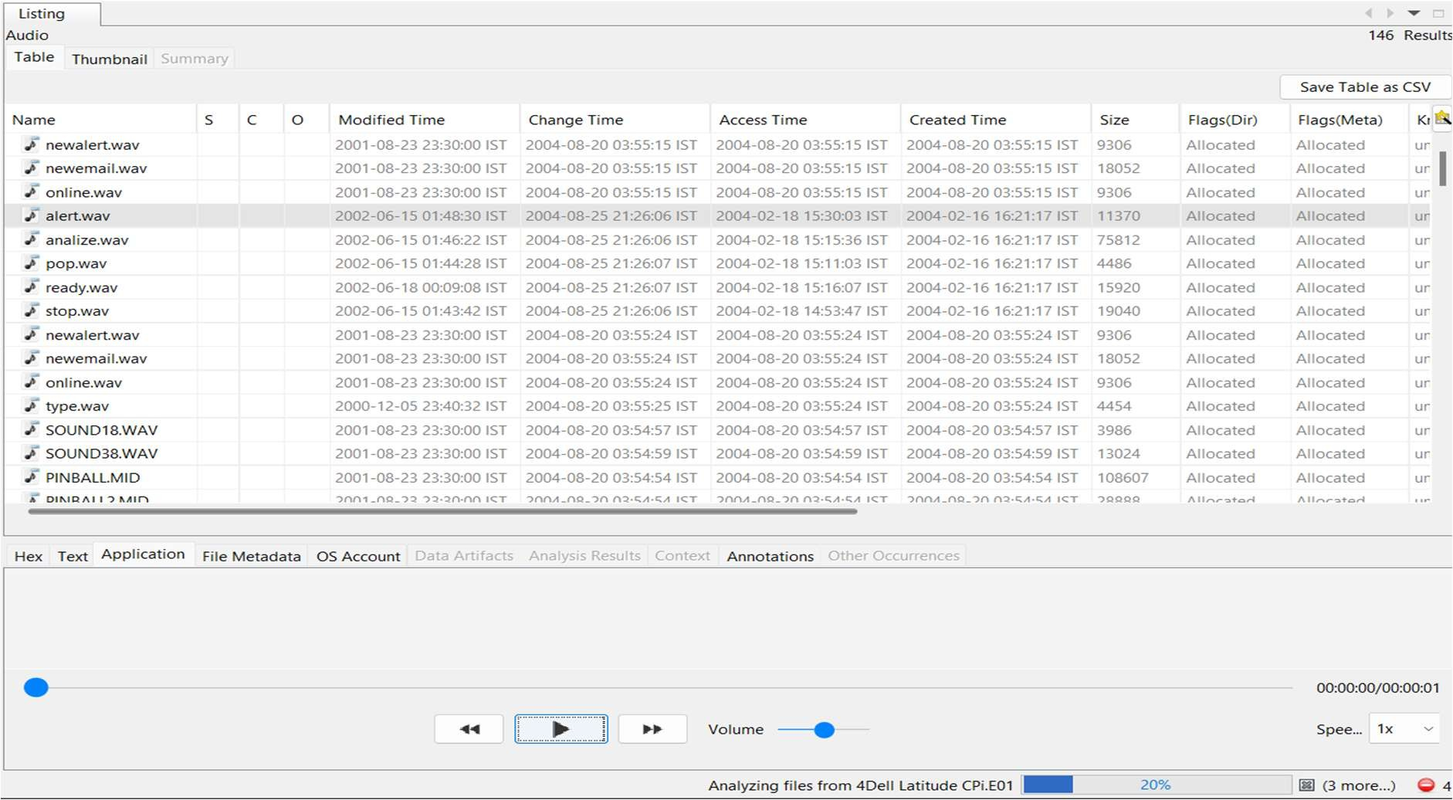
Figure 6: Detailed analysis and viewing extracted files (e.g., Audio playback and metadata)

Step 6: Reporting and Case Closure

- Click on Generate Report from the main toolbar.

- Choose the desired report format (e.g., Excel Report, HTML Report) under the Select and Configure Report Modules window.
- Click Next and select the specific result types to include (e.g., Accounts, E-Mail Messages, etc.).
- Review the generated report to ensure all relevant information and exported artifacts are accurately documented.
- Once the investigation is complete, close the case within Autopsy and archive all data according to organizational policies.

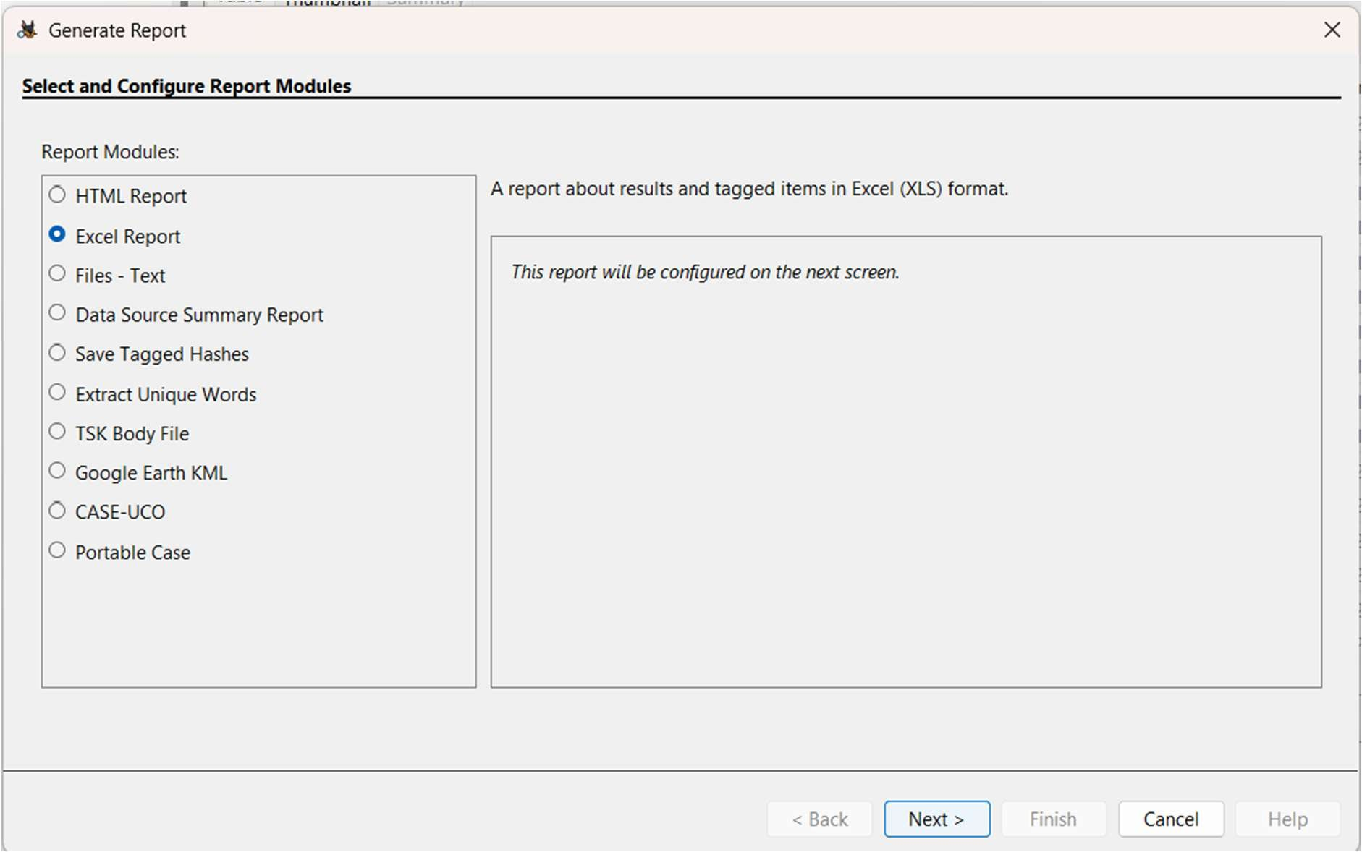
Figure 7: Selecting the report module format

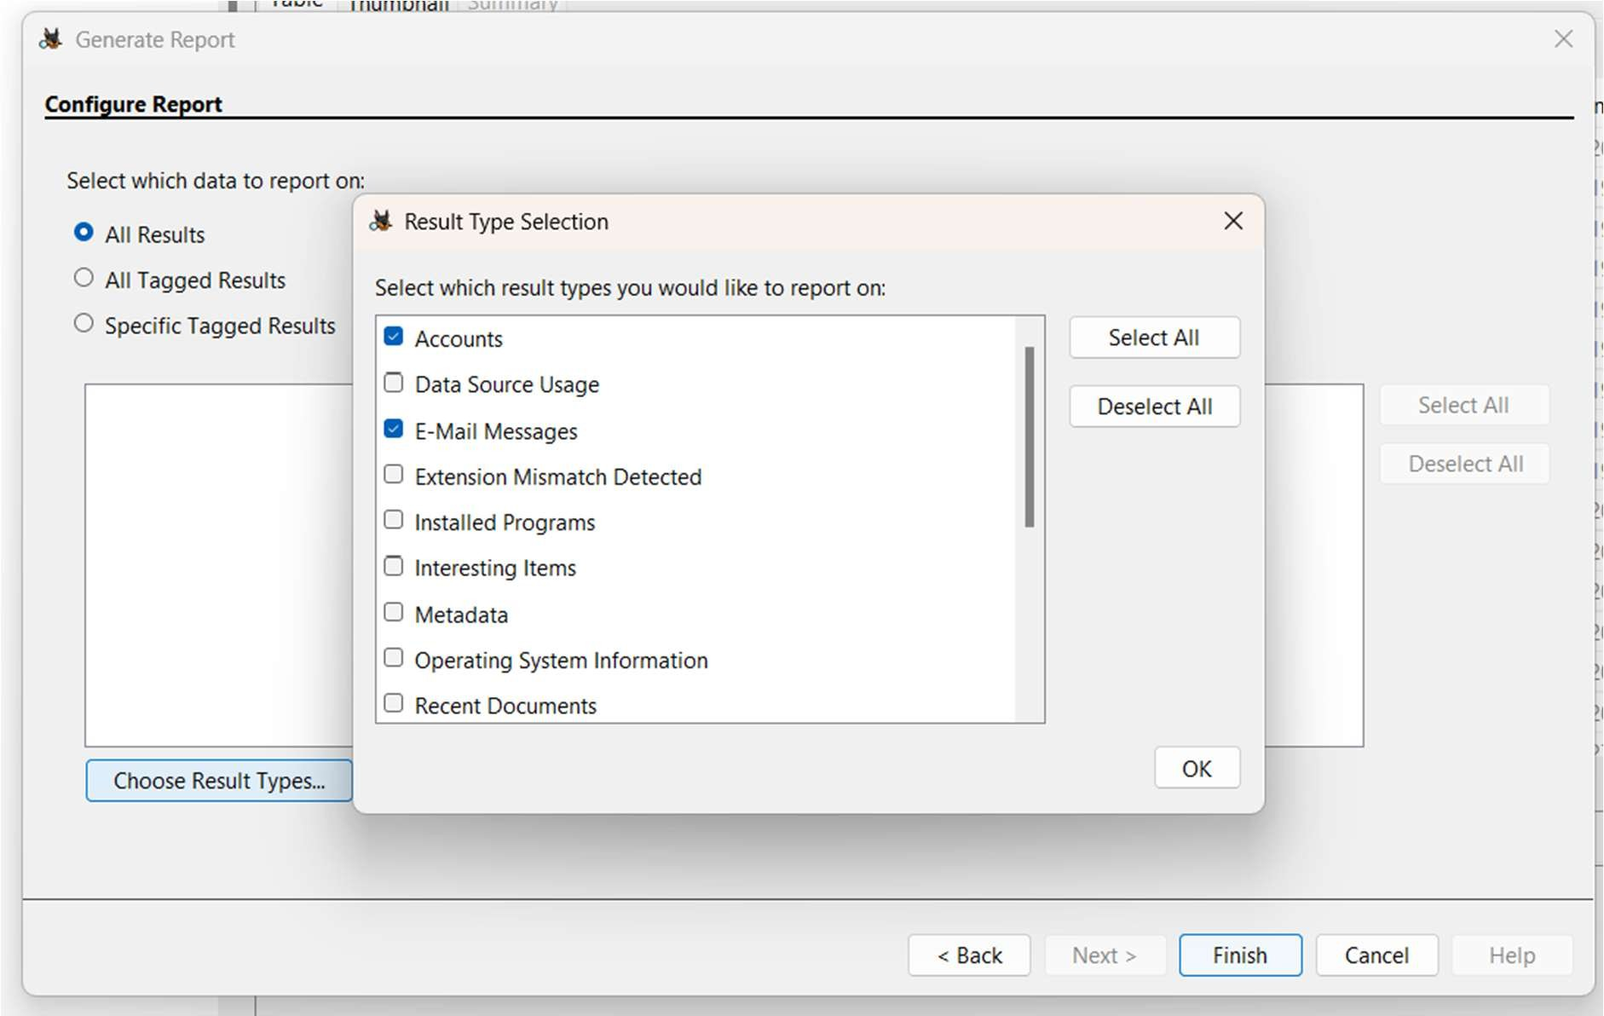
Figure 8: Configuring the report by selecting specific tagged data

RESULT

The digital forensics experiment was successfully completed. A new case was established in Autopsy, and the provided .E01 disk image evidence was successfully imported, analyzed using ingest modules, and documented via the reporting feature.

